**–––––––––––––––––––––––––––––**

**Software Design Specification**

**for**

**XFit Exercise App**

Version 1.0

**Prepared by**

**Reiniel Fernandez**

**Javier Herdocia**

**Mario Orellana**

**Gustavo Zapata**

**Group 3**

**2022-01-29**

# Table of Contents

**Table of Contents** **2**

**Revision History** **10**

**1. Introduction** **11**

1.1 Purpose 11

1.2 Document Conventions 11

1.3 Intended Audience and Reading Suggestions 11

1.4 Product Scope 12

1.4.1 Purpose 12

1.4.2 High Level Flow 12

1.5 References 13

**2. Overall Description** **13**

2.1 Product Perspective 13

2.2 Product Functions 13

2.3 User Classes and Characteristics 14

2.4 Operating Environment 14

2.5 Design and Implementation Constraints 15

2.6 User Documentation 15

2.7 Assumptions and Dependencies 15

**3. External Interface Requirements** **17**

3.1 User Interfaces Overview 17

3.2 Hardware Interfaces 20

3.3 Software Interfaces 20

**4. Design Considerations** **20**

4.1 Assumptions and Dependencies 20

4.2 General Constraints 21

4.3 Development Methods 21

**5. System Architecture** **22**

5.1 Architectural Strategies 22

**5.2 High level Overview of System Architecture** **22**

**6. Human Interface Design** **25**

6.1 Site Map 25

6.2 Screen Images 26

6.3 Screen Objects and Actions 35

**7. Detailed System Design** **37**

**7.1 Data Structures** **37**

**7.2 Exercise/ ExerciseDB Entity** **37**

7.2.1 Responsibilities 37

7.2.2 Uses/Interactions 37

7.2.3 Constraints 38

7.2.4 Composition 38

7.2.5 Resources 42

7.2.6 Processing 42

**7.3 Muscle / MuscleDB Entity** **45**

7.3.1 Responsibilities 45

7.3.2 Uses/Interactions 45

7.3.3 Constraints 45

7.3.4 Composition 46

7.3.5 Resources 46

7.3.6 Processing 47

**7.4 Image Entity** **47**

7.4.1 Responsibilities 48

7.4.2 Uses/Interactions 48

7.4.3 Constraints 48

7.4.4 Composition 48

7.4.5 Resources 49

7.4.6 Processing 49

**7.5 ExerciseImage Entity** **50**

7.5.1 Responsibilities 50

7.5.2 Uses/Interactions 50

7.5.3 Constraints 50

7.5.4 Composition 50

7.5.5 Resources 51

7.5.6 Processing 51

**7.6 ExerciseMuscle Entity** **52**

7.6.1 Responsibilities 52

7.6.2 Uses/Interactions 52

7.6.3 Constraints 52

7.6.4 Composition 52

7.6.5 Resources 53

7.6.6 Processing 54

**7.7 FavoriteExercise Entity** **54**

7.7.1 Responsibilities 54

7.7.2 Uses/Interactions 54

7.7.3 Constraints 54

7.7.4 Composition 55

7.7.5 Resources 56

7.7.6 Processing 56

**7.8 Equipment / EquipmentDB class** **56**

7.8.1 Responsibilities 56

7.8.2 Uses/Interactions 56

7.8.3 Constraints 57

7.8.4 Composition 57

7.8.5 Resources 59

7.8.6 Processing 59

**7.9 EquipmentImage Entity** **61**

7.9.1 Responsibilities 61

7.9.2 Uses/Interactions 61

7.9.3 Constraints 61

7.9.4 Composition 61

7.9.5 Resources 62

7.9.6 Processing 62

**7.10 ExerciseEquipment Entity** **63**

7.10.1 Responsibilities 63

7.10.2 Uses/Interactions 63

7.10.3 Constraints 63

7.10.4 Composition 63

7.10.5 Resources 64

7.10.6 Processing 64

**7.11 Plan / PlanPK Entity** **65**

7.11.1 Responsibilities 65

7.11.2 Uses/Interactions 65

7.11.3 Constraints 65

7.11.4 Composition 65

7.11.5 Resources 67

7.11.6 Processing 67

**7.12 User / User DB entity** **67**

7.12.1 Responsibilities 67

7.12.2 Uses/Interactions 68

7.12.3 Constraints 68

7.12.4 Composition 69

7.12.5 Resources 71

7.12.6 Processing 71

**7.13 UserEquipment Entity** **73**

7.13.1 Responsibilities 73

7.13.2 Uses/Interactions 74

7.13.3 Constraints 74

7.13.4 Composition 74

7.13.5 Resources 75

7.13.6 Processing 75

**7.14 DBUtil Entity** **75**

7.14.1 Responsibilities 75

7.14.2 Uses/Interactions 76

7.14.3 Constraints 76

7.14.4 Composition 76

7.14.5 Resources 76

7.14.6 Processing 76

**7.15 Cookie Util Entity** **77**

7.15.1 Responsibilities 77

7.15.2 Uses/Interactions 77

7.15.3 Constraints 77

7.15.4 Composition 77

7.15.5 Resources 77

7.15.6 Processing 77

**7.16 Password Util Entity** **78**

7.16.1 Responsibilities 78

7.16.2 Uses/Interactions 78

7.16.3 Constraints 78

7.16.4 Composition 78

7.16.5 Resources 79

7.16.6 Processing 79

**7.17 Email Util Entity** **82**

7.17.1 Responsibilities 82

7.17.2 Uses/Interactions 82

7.17.3 Constraints 82

7.17.4 Composition 82

7.17.5 Resources 83

7.17.6 Processing 83

**7.18 UserController Servlet** **84**

7.18.1 Responsibilities 84

7.18.2 Uses/Interactions 84

7.18.3 Constraints 84

7.18.4 Composition 84

7.18.5 Resources 87

7.18.6 Processing 87

**7.19 ExerciseController Servlet Entity** **97**

7.19.1 Responsibilities 97

7.19.2 Uses/Interactions 97

7.19.3 Constraints 97

7.19.4 Composition 97

7.19.5 Resources 98

7.19.6 Processing 98

**7.20 Image Servlet Utility** **102**

7.20.1 Responsibilities 102

7.20.2 Uses/Interactions 102

7.20.3 Constraints 102

7.20.4 Composition 102

7.20.5 Resources 102

7.20.6 Processing 103

**7.21 Email Servlet Utility** **104**

7.21.1 Responsibilities 104

7.21.2 Uses/Interactions 104

7.21.3 Constraints 104

7.21.4 Composition 104

7.21.5 Resources 105

7.21.6 Processing 105

**7.22 Equipment Controller** **106**

7.22.1 Responsibilities 106

7.22.2 Uses/Interactions 106

7.22.3 Constraints 107

7.22.4 Composition 107

7.22.5 Resources 107

7.22.6 Processing 107

**7.23 PlanController Servlet** **107**

7.23.1 Responsibilities 108

7.23.2 Uses/Interactions 108

7.23.3 Constraints 108

7.23.4 Composition 108

7.23.5 Resources 109

7.23.6 Processing 109

# Revision History

| **Name** | **Date** | **Reason For Changes** | **Version** |
| --- | --- | --- | --- |
| Javier Herdocia | 2022-01-29 | Initial Draft | 1.0 |
| Javier Herdocia | 3/23/2022 | Revision | 1.1 |
| Javier Herdocia | 4/7/2022 | Final Draft | 2.0 |

# 1. Introduction

## 1.1 Purpose

XFit is a web application that will help users plan daily workout routines according to the availability of equipment they have at home. The application is intended to help users find and learn new exercises that they can perform at home in addition to organizing weekly routines that will contribute users to find a satisfying and consistent exercise pattern that works best and provides a summary for tracking and calorie monitoring purposes. This SRS will be used in project’s later phases, such as system design, database design, implementation and testing. This document will serve to describe the specifics of our design and how the application fulfills the requirements that were specified.

## 1.2 Document Conventions

All system development activities should follow the final version of this document. Any discrepancy that is found during later phases should be modified subject to SRS. However, this document may be subject to change dependent on the decision of the group members.

## 1.3 Intended Audience and Reading Suggestions

This document is intended for readers who are:

* Development staff:

For accurate guidelines and records on design patterns.

* Marketing staff:

For a thorough understanding of how the application will handle and perform specified requirements.

* Project managers:

For accurate records and description of design guidelines and object oriented methods.

## 1.4 Product Scope

XFit offers a convenient and efficient way of allowing users to find what type of exercises they can do based on the equipment they currently have in their possession. Each exercise will have a description and example of how they can be done and will be also filtered for users who are either experienced or beginners to help them have a more comfortable experience using the application.

### 1.4.1 Purpose

XFit designs and implements the application to fulfill all the vision statements. Supported by a well design database, all available exercises, sets of repetitions and modalities are integrated together and can be accessed easily through a single point. A friendly user interface is provided so that various combinations of search criteria can be fetched from the user and generates corresponding database search and results. XFit will provide user and administration modules, administration being the portion that controls and maintains the users, equipment and exercise details.

### 1.4.2 High Level Flow

A user will visit the web page and choose to make an account by clicking register from the home page. Users will insert a strong password, username and valid email address to have them sent a verification code to confirm their email address. Once they confirm an email address, users can then select equipment that they own for additional filtering later on. After registration, users will be redirected to the home page where they can select to view the exercise list page.

XFit will filter exercises from an existing database of available exercises based on User profile configurations that they create upon registering a new account following proper registration procedures. Users then can match equipment they own at home with what is available from our application. Users who have only dumbbells for example, will see exercises that meet the requirements of dumbbells. By clicking planner from the home page, users can create an exercise routine for each day of the week with a convenient user interface. Options for exercises can be filtered according to user preferences such as exercises favorited by the user or application exercises that users have available equipment for. After a plan has been made, the user will select save to save changes to their plan.

At some points, users can create a custom exercise with a title and description and can configure their user account.

## 1.5 References

### Simple Train Simulator SDS by Leva Kurginyan

# 2. Overall Description

## 2.1 Product Perspective

This project was founded on the idea of making a convenient way to inspire users to dedicate themselves to a consistent and efficient exercise routine. Other similar applications offer similar services but don't offer an user friendly interface for helping users plan out day specific routines. So xfit seeks to provide this service for both beginners and experienced users already familiar with making an exercise routine.

## 2.2 Product Functions

This product will provide guests with the ability to view all application provided exercises in a listed format. Users will have the functionality to create and configure their own personal user account which will be saved onto a server side database. Users can personalize what kind of equipment matches the ones they own at home. Users can also customize and create their own personalized exercises which will be specific to them and they could add to an Exercise routine.

After creating an account and logging in, users will be presented with 'today's exercise' featuring a list of exercises the user has planned for the current day. The main feature of our application is the ability for users to create an exercise routine for each day of the week with a convenient user interface. Options for exercises can be filtered according to user preferences such as exercises favorited by the user or application exercises that users have available equipment for.

## 2.3 User Classes and Characteristics

The types of users anticipated to use their application are:

* Beginners:

Users starting out an exercise experience will Utilize this app through the planner feature which will help them organize an exercise routine that best suits them. Beginners will also utilize the detailed description and image guidance that will be provided in each system exercise featured in the application.

* Experienced:

Users who may already have a grasp on what types of exercises are best suited for them and how to apply them properly will find the planner feature best suited for them to organize exercises to know ahead of time what their routine will look like for a given week.

* Administration:

Administrative users will be able to login with specific credentials to have access to the administrative panel to configure existing user accounts and exercises and equipment details.

## 2.4 Operating Environment

The system will run on all applications which run chrome, Internet explorer, and firefox web browsers. Mobile deployment will run on most mobile web browsers with bootstrap technology applying proper page scaling.

In order for full functionality of the application, the web browser must allow cookies to be stored on the client system.

## 2.5 Design and Implementation Constraints

* Deadline constraints:

Due to delivery deadlines, certain features originally planned to be added in the first release had to be and saved for potential future releases.

* System Memory Constraints:

The scope and extensibility of certain features had to be limited to not overload system memory limitations.

* Language compliance constraints:

All imported technologies and libraries for system extensions need to comply with the standard Java language.

## 2.6 User Documentation

An built in support system for user account recovery in the event of a forgotten/misplaced password will be provided for users.

A detailed and descriptive for each application provided exercise will give users full guidance and support to assist users.

## 2.7 Assumptions and Dependencies

* Users of XFit are assumed to have a computer with internet connection.
* Users familiarity with the terminology and the names of the routines is expected as this is not a training or educational application, it is for users who have a basic idea of exercises and equipment routines.
* Xfit uses exercises from a third party database and therefore it must follow their rules and terms of use.
* In the first version only the English language will be supported.
* Users must have an existing email account in order to have full site functionality
* Once a user has registered and verified an email address, for the initial version of this application a user cannot change their email address.
* Equipment choices, Workout plans, and User custom exercises are exclusive to each user and cannot be shared among users.
* Users are assumed to be able to manually remove exercises from their routine if they want a type of routine that will reset at the end of a given day.

### 

# 3. External Interface Requirements

## 3.1 User Interfaces Overview

**Images are displayed in section 6, Human Interface Design.**

Guest Home Page

Upon initial use of the application which will be in a GUI web format, Users will view the home page in its guest viewing with no user login necessary. Home page features about sections and the primary options for viewing application provided exercises and the options to sign in and register in the navigation bar.

Registration Modal

A new user will select the register option to create an account with a username, email, and password. Users will need to use an email that does not currently exist in the site database and a password that fulfills the qualities of a ‘strong’ password. Each will be inputted in their respective input fields.

Email Confirmation

Afterwards users will have to confirm their email address in an email confirmation page where they will receive an email with a temporary generated code. Users will have the option to change their email address in this page or resend a new generated code that will be sent to their email address by selecting either the change email or resend code option respectively. Users will input their code in an input text box.

Equipment Selection/My Equipment

Users afterwards will select equipment from this page to match what they own at home and save it into their account. This can be skipped and saved for later by selecting skip for later. The equipment is displayed in a grid format with an image and title for each. Multiple equipment can be selected and then saved by selecting the save button. This page can be returned to by selecting my equipment from their account options to edit.

Main Home Page

After users have registered or have logged in will be able to see the main home page with additional options on the navigation bar of Today's Workout and the Planner. The sign in and register options will be replaced with the account option for the user which will have a drop down menu of My profile, My equipment, My exercises, and log out.

Account page

Clicking my profile from the account options will open a page displaying the brief account details of the user with an edit button to configure account details. To edit the account, username, email, and password will be displayed in input text boxes and any changes can be saved by clicking the save button or reverted using the cancel button.

Exercise Detail Page

When a user clicks on a given exercise from a page where exercises are listed (excluding the routine planner), a page detailing the exercise will be displayed with the title and a brief description of the specific exercise and all the steps on how to properly complete the exercise. The page will feature the muscles that are worked on with the exercise and the equipment (if any) that are used during the exercise with detailed pictures for the user on proper posture for the exercise.

User Exercises Page

Clicking my exercises from the account options will open a page where users can view exercises created by the user in a list format. Each exercise in the list can be deleted, favorited, or configured by clicking the trash, heart, and pencil button respectively. Clicking an exercise to view it will display the title and description for a user created exercise and an edit button to edit the title and description fields of the given custom exercise.

Main exercise list page

Clicking the exercises button on the navigation bar will open a page displaying a list of all exercises in the application including user custom exercises. The list will have options to search for the title of an exercise and also to filter exercises based on custom, favorited, or if the user has the equipment for them. Application exercises will feature options to view and favorite, but user custom exercises will have options to delete, edit and favorite with a trash, pencil, and heart icon respectively.

Today's workout page

Clicking the today's workout button on the navigation bar or logging in to the site with an existing user account will open a page that has all the exercises the user has prepared for the routine for the day in the planner and an edit button to edit the routine for the day. Each exercise will be ordered and listed in a checklist format, displaying the reps and cycles for each exercise and the title for each exercise.

Schedule page

Clicking the planner button from the navigation bar will open a page with 7 tables for the 7 days of the week with the titles of each exercise planned for that day in a list format. Each table can be selected to view and or edit.

Day-view page

Clicking to edit a routine for a day either from today's workout or from the schedule page will open the day view page which will display the list of all exercises currently planned for each day of the week (if any). All exercises will have an option to remove it from the routine page, to favorite the exercise with a heart icon, and an option to edit the reps and cycles. A separate table on the page will feature a list of all exercises from the application with the option to filter exercises similar to the main exercise list page. This list on the page will allow users to add exercises to their routine by selecting an arrow to add it. If a user has made changes without saving and attempts to leave the page, the site will display a confirmation message to confirm with users.

## 3.2 Hardware Interfaces

This application will require any form of user input such as a touchpad, mouse/keyboard and will require users to meet system requirements for running a web browser.

## 3.3 Software Interfaces

### The application will be interfaced with the most updated web browser preferred by the user with cookies enabled. Application will be provided by an Apache Tomcat Server. The application will interact through standard SQL requests with the application database system using MariaDB. HttpSession libraries will be used to save cookies to the client for additional system functionality.

The database will receive queries from the BeanDBs built in queries depending on user inputs and exchange class objects, string, long, and integer data from database tables.

### 

# 4. Design Considerations

## 4.1 Assumptions and Dependencies

Full functionality of the application assumes that the user has full web connectivity and has cookies enabled on the given browser they are using to access the application. Users must have an existing email account in order to register and sign in to the application. Users can only sign in with an existing email account. Once a user uses an email to register, they cannot change email address and instead will have to create a new account. User plans, equipment choices, and user custom exercises are exclusive to each user and cannot be shared.

## 4.2 General Constraints

Due to the scope of application being web based, design of the system is limited in order to work properly due to limited memory. As such certain features that may require the consistent use of our MariaDB interface such as when we want to load all exercises from the database have to be reconsidered during implementation.

Given the technologies used for implementation of the application, the proper interfaces and ports must be used in the given components in our architecture that these technologies are interacted with. For example, all components connecting to the database must import javax.persistence.

Exercises Images used must be credited with the source reference and author within the implementation and on the web page in which they are displayed.

## 4.3 Development Methods

### The model portion of the architecture must be implemented using an Object Oriented approach using the standard java language. Each java bean of the model communicating with the database must have a corresponding beanDB class that will contain the query methods for the given bean. The data of the application must be handled using standard MySQL query language. The view of the architecture using HTML/JSP.

# 5. System Architecture

## 5.1 Architectural Strategies

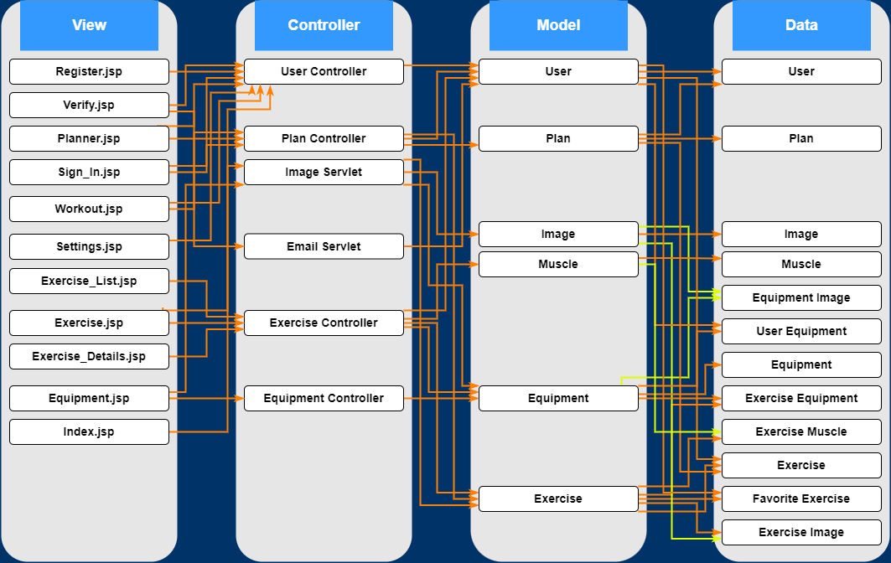

For our architecture, we decided to use a standard MVC design pattern in which we divided our view (front end), controller (logic), model (structure and data integrity), and data (data storage) into their own separate components.

## 5.2 High level Overview of System Architecture

For our architecture we have view, controller, model and data components each representing the major domain classes of our application which consists of a User, Exercises, Plans, Equipment. In our view component, jsp pages are used for detailing and displaying elements of a given domain class such as the exercise_details.jsp and exercise_list.jsp. Other jsp pages such as Settings and verify are used for enabling access to certain parameters of the domain classes in the other components for the user, for example how the settings allows users to configure their user account stored in the database through the User class in the model.

Our controller classes (servlets), use elements from the view and methods defined in the model to control the logic behind the view and what to display to the user upon given requests. The servlet will determine the action of the user to call the appropriate model methods used in the DB classes.

The model components are separated into four different types of classes:

* **JavaBean:**

These are very generic and basic java classes with simple attributes and getters and setters. For our application, we use java beans for this same purpose but also to define extra methods such as ones that take associations of the class through its id like the ExerciseMusclesById: Collection<ExerciseMuscle> attribute from the exercise class. Each attribute in our bean classes have definitions that match them to the table in the database they represent using javax.persistence by defining the column names and constraints for each. Attributes may also have mapping to other tables by defining which other tables have this class represented as an id through @joincolumn.

* **Joint Classes:**

These classes are similar to java bean classes except primarily represent the joint tables within the database between major domain classes such as ExerciseImage, which is a the joining of Exercise and Image representing what images are used by which specific exercise.

* **Primary Key (PK) classes:**

The joint tables have two composite keys in the database that are from the two major domain classes that those tables represent. For example, the ExerciseImage table will have a primary key from table Image and table Exercise. These PK classes are used to essentialize the composite keys into a single primary key that can be used to represent the joint table.

* **DB classes:**

Each of the primary domain classes like Exercise, User, Plan, etc, have a DataBase class which contains the query methods used by the JavaBean class associated with it. Each method that affects the database utilizes EntityManagerAPI that creates a persistence to the database and uses the query defined in the JavaBean.

### 

# 

# 

# 

# 

# 

# 

# 6. Human Interface Design

# 6.1 Site Map

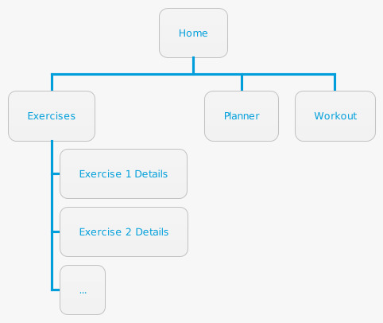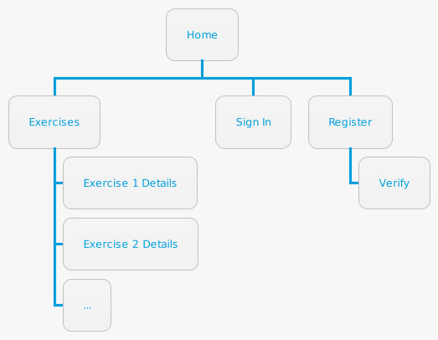

# 

# 6.2 Screen Images

**Home Page**

**6.1.1 Home Page**

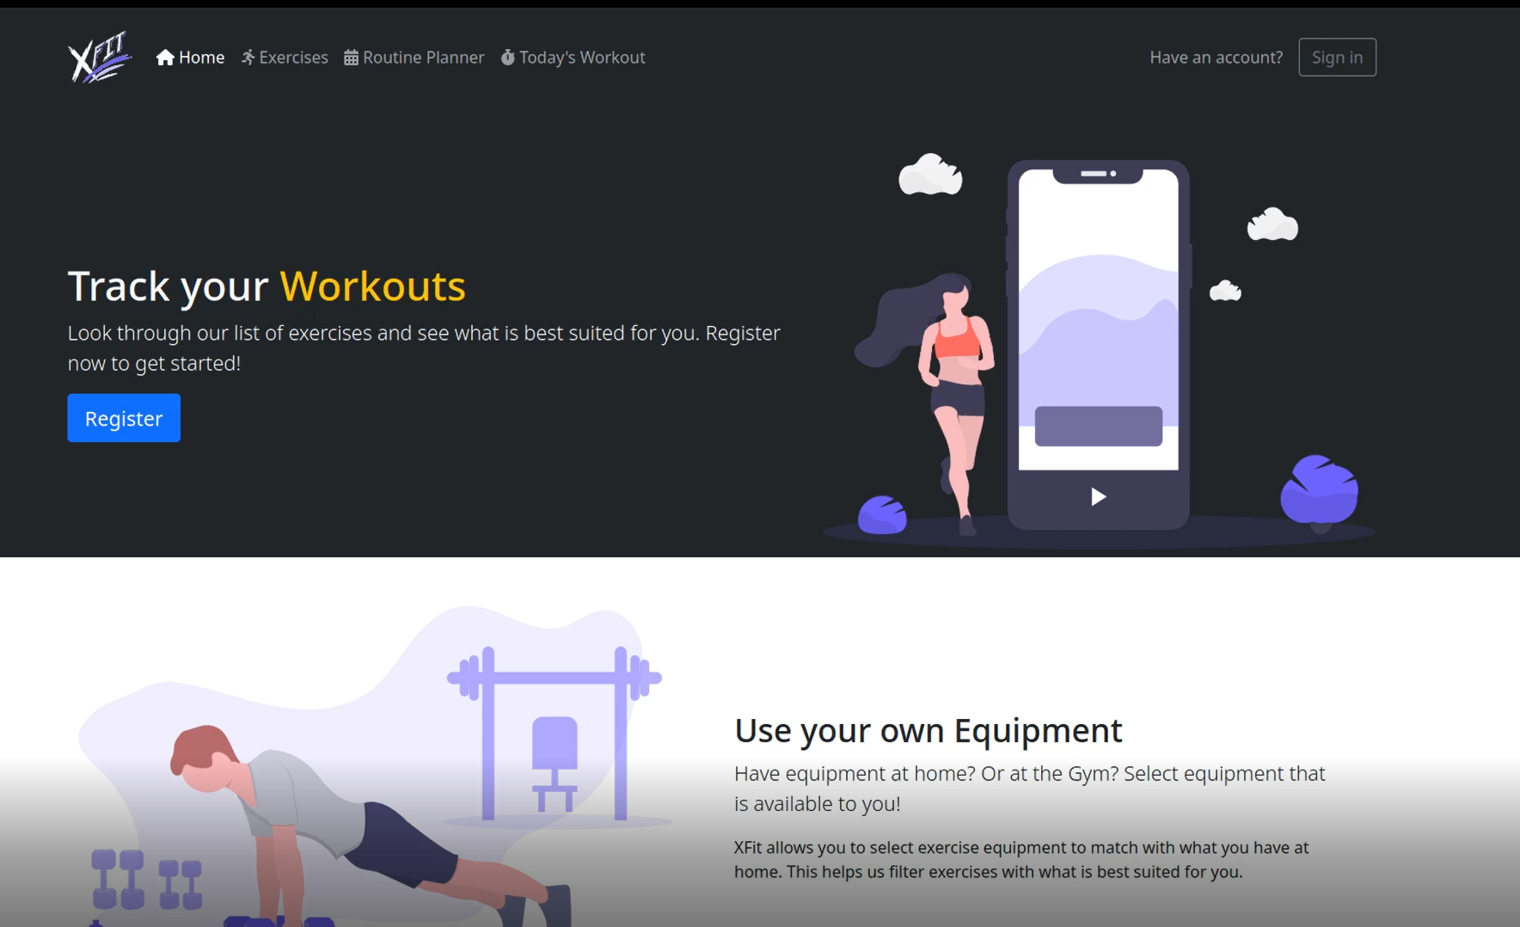

**6.1.2 Home Page**

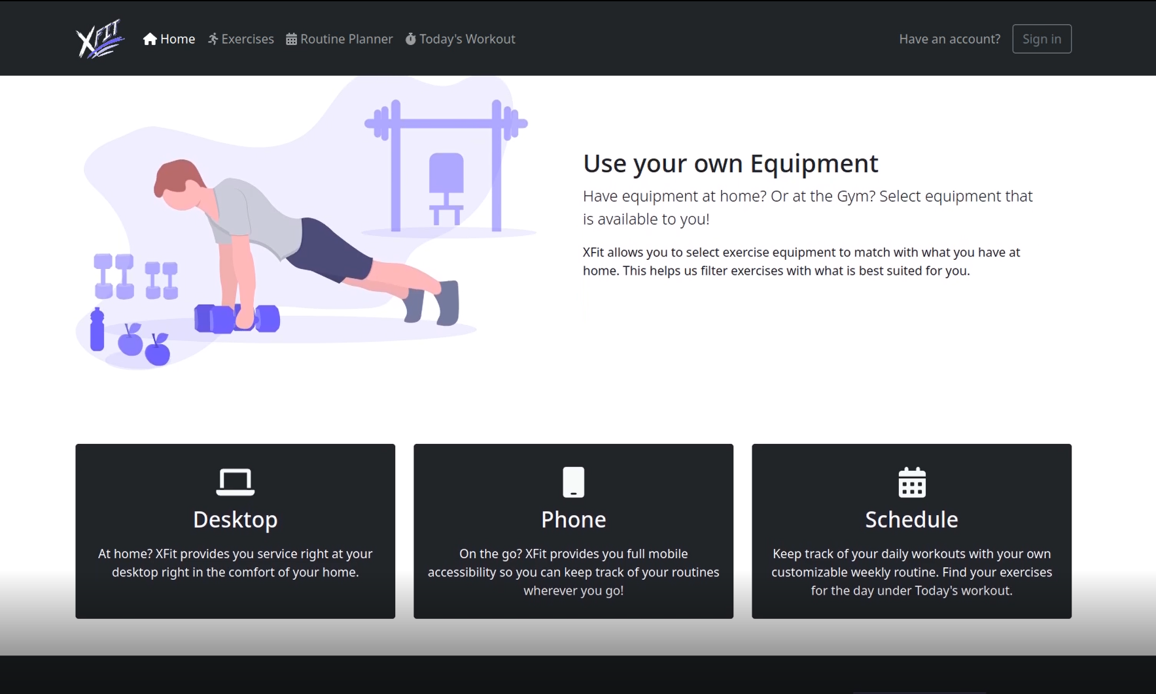

**6.1.3 Home Page**

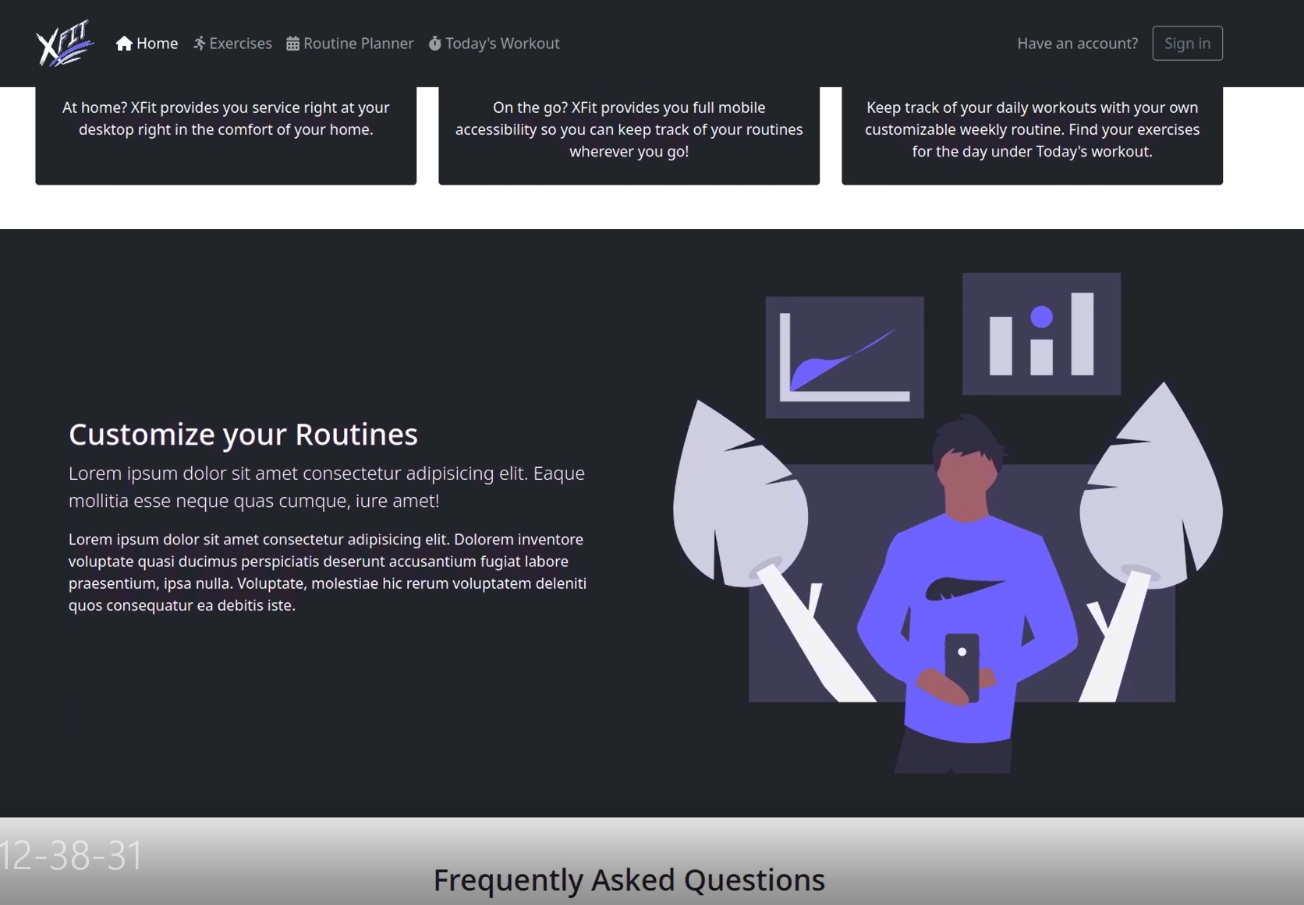

**Register**

**6.2.1 Register Page**

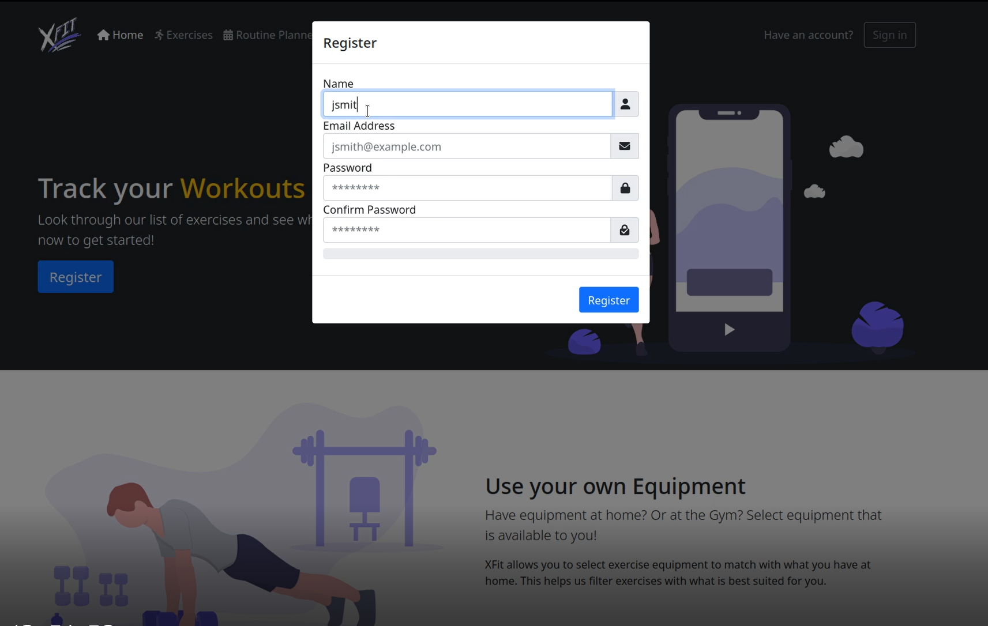

**6.2.2 Bad Password**

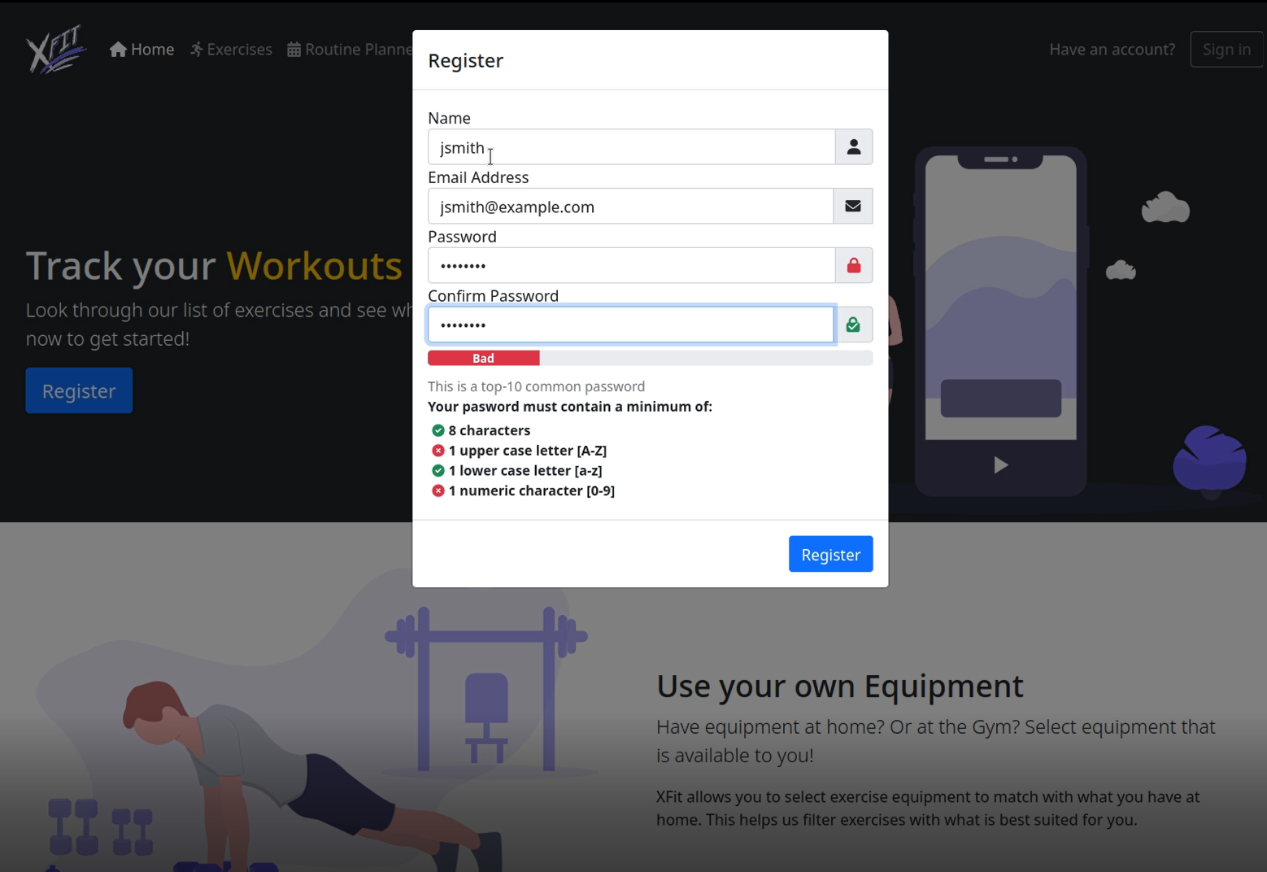

**6.2.3 Strong Password I**

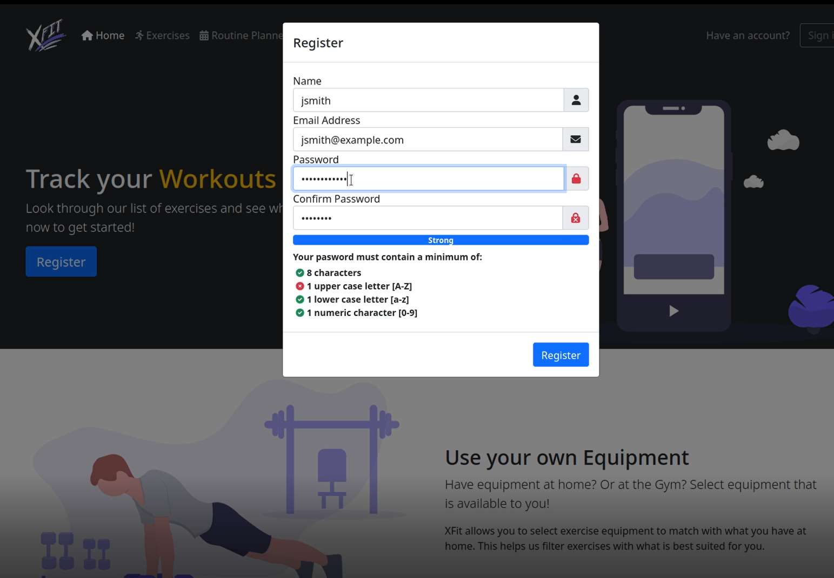

**6.2.4 Strong Password II**

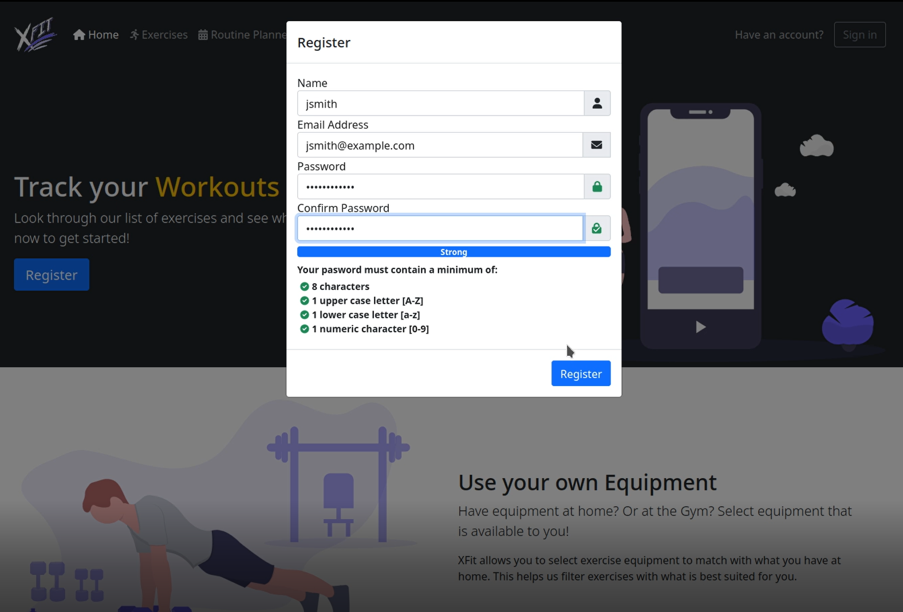

**6.3.1 Exercises Page**

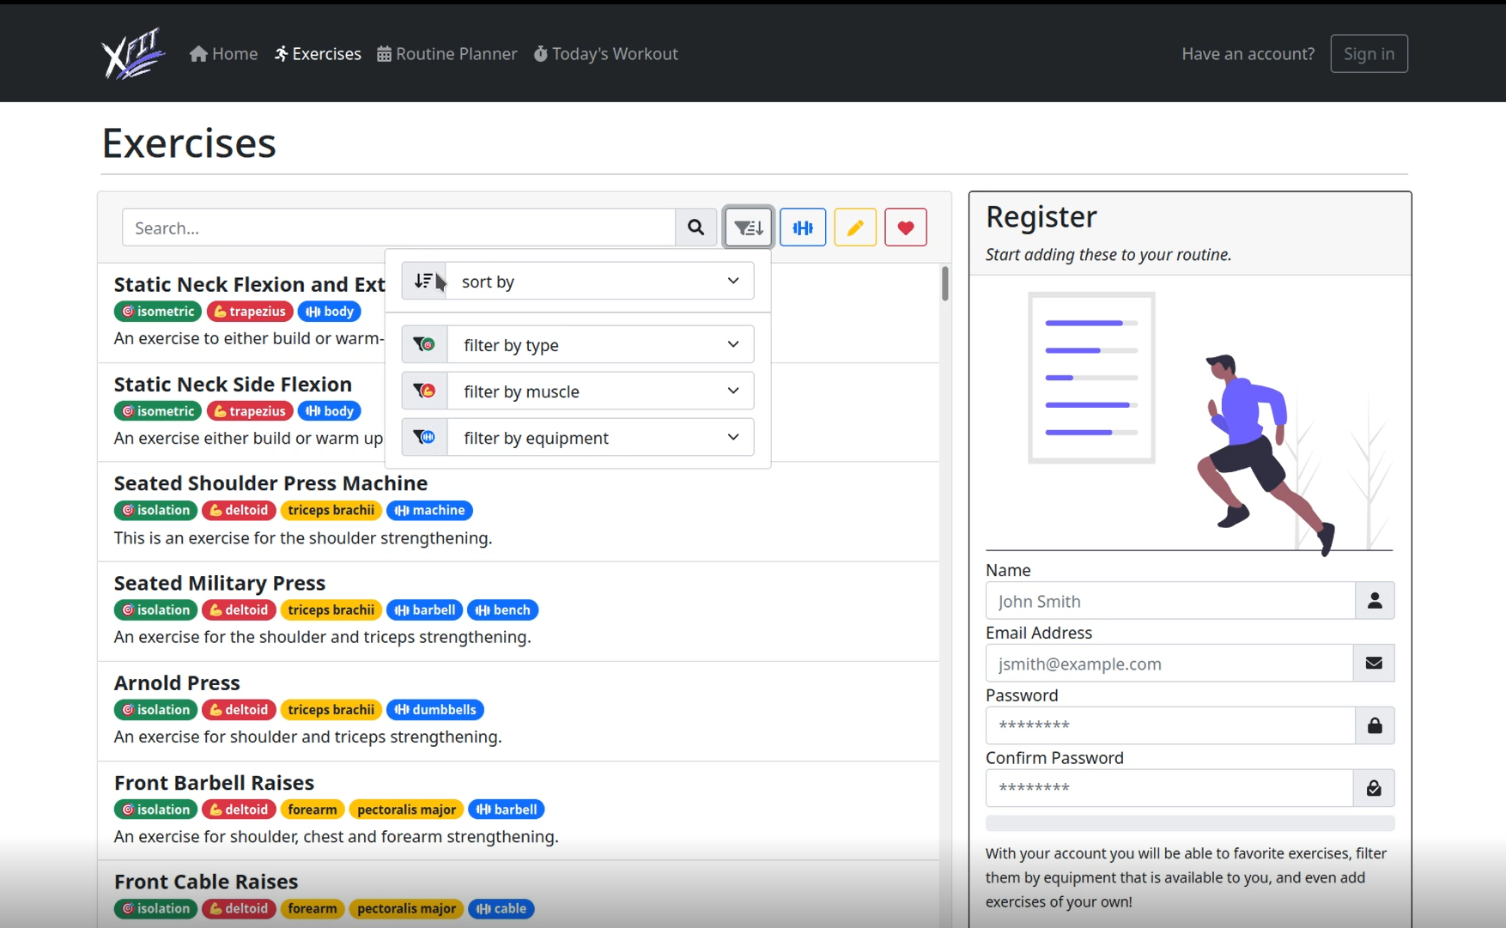

**6.3.2 Exercises Page -Sort By Equipment**

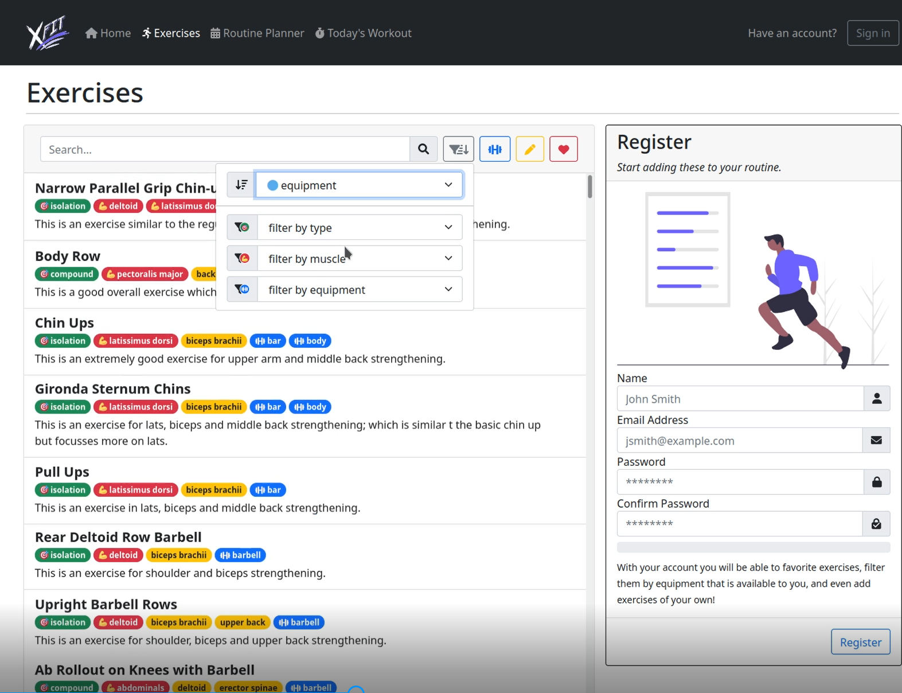

**6.3.2 Exercises Page -Sort by Multiple**

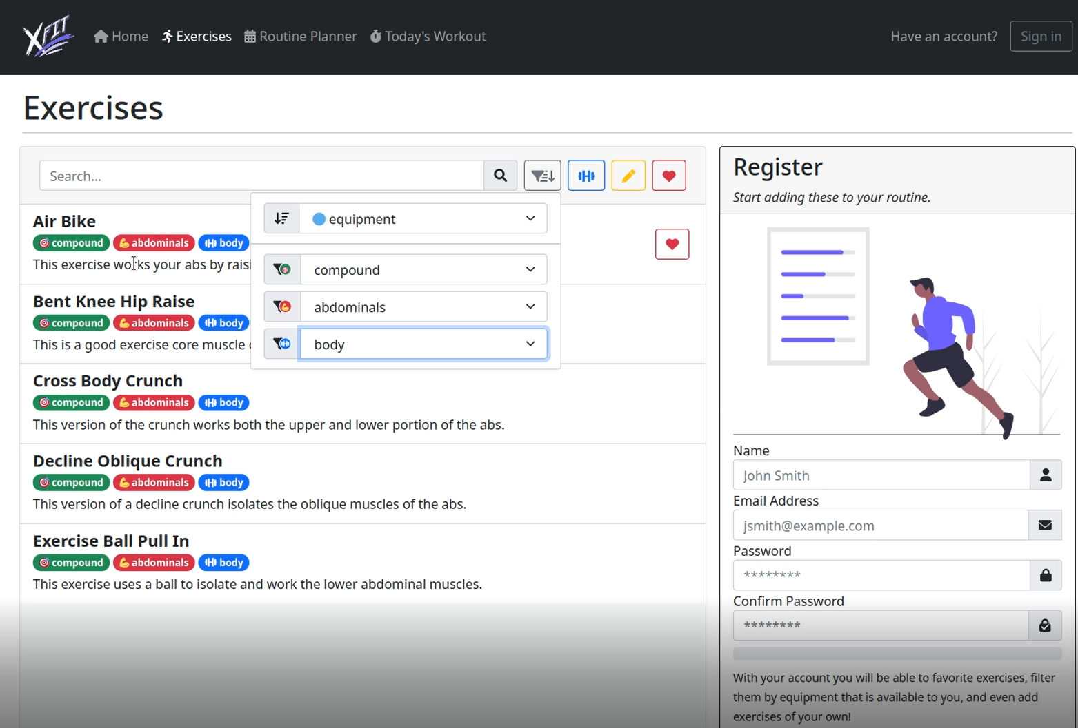

**6.3.2 Exercises Page - Exercise Item**

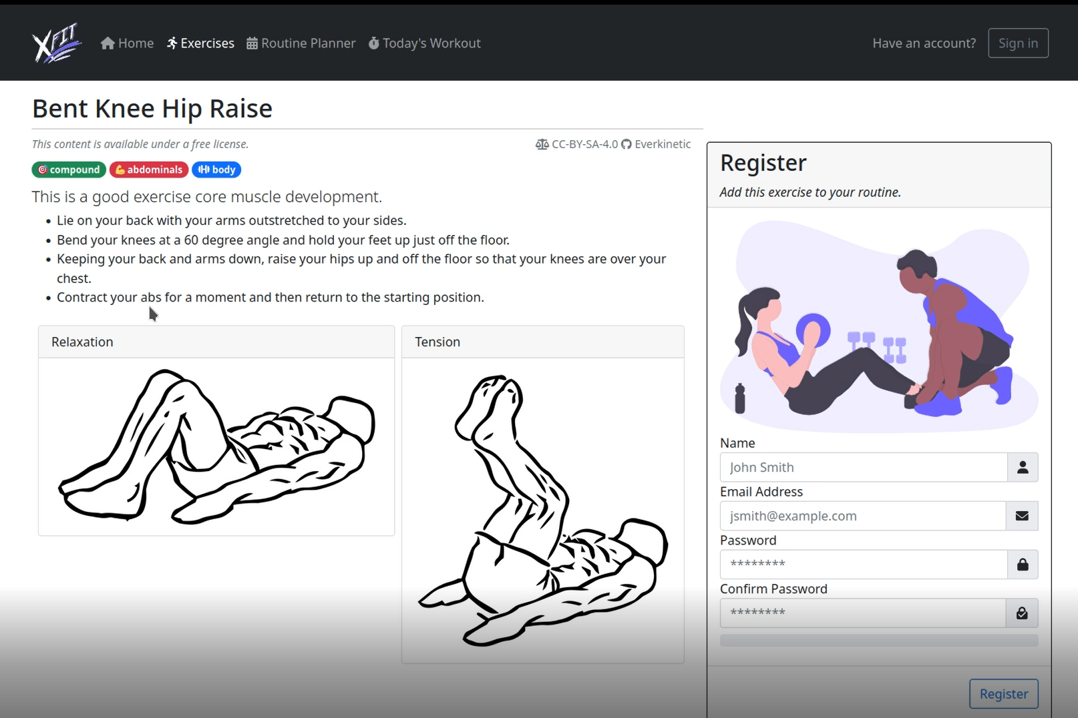

**6.3.2 Exercises Page - Exercise Look Up by Text**

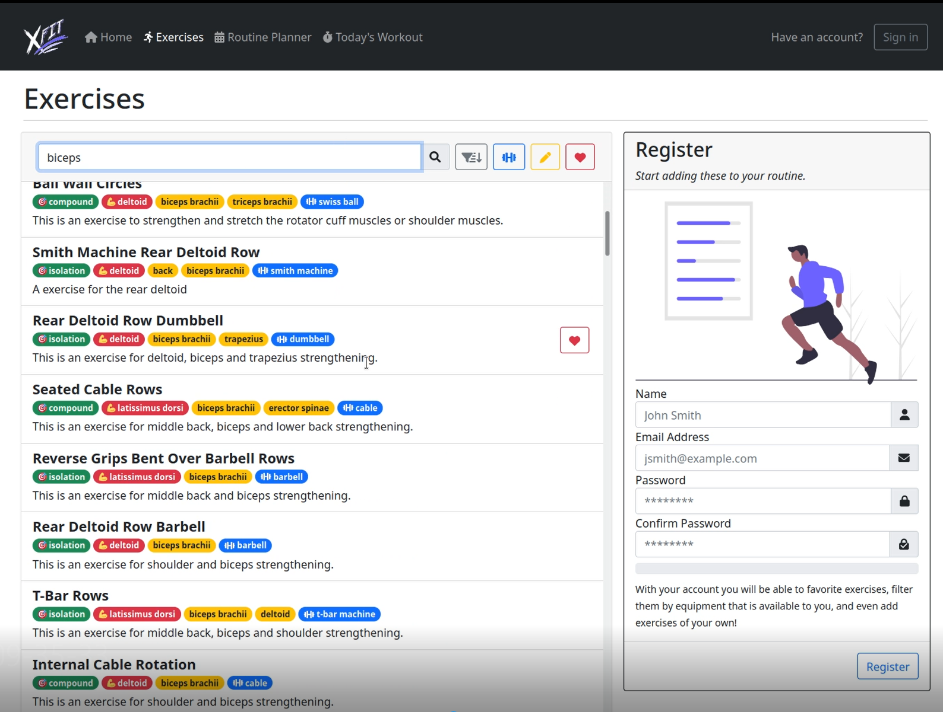

**6.4.1 Equipment**

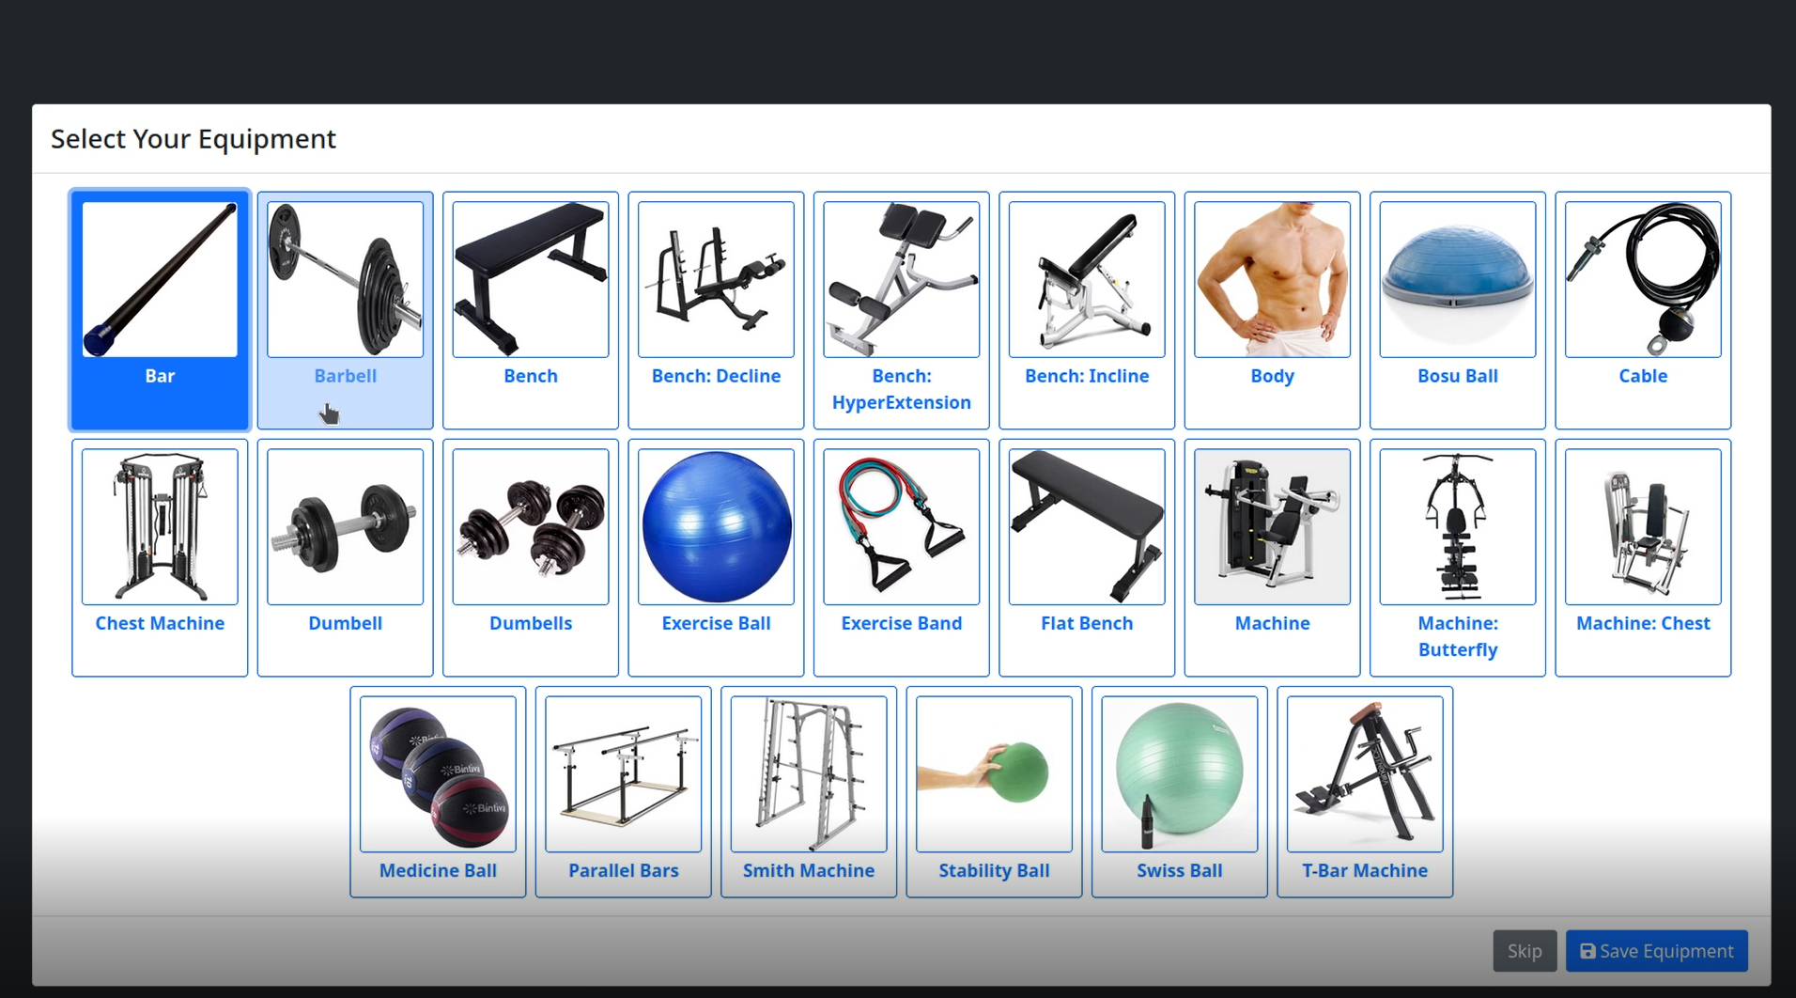

**6.4.2 Equipment - Save Selected Equipment**

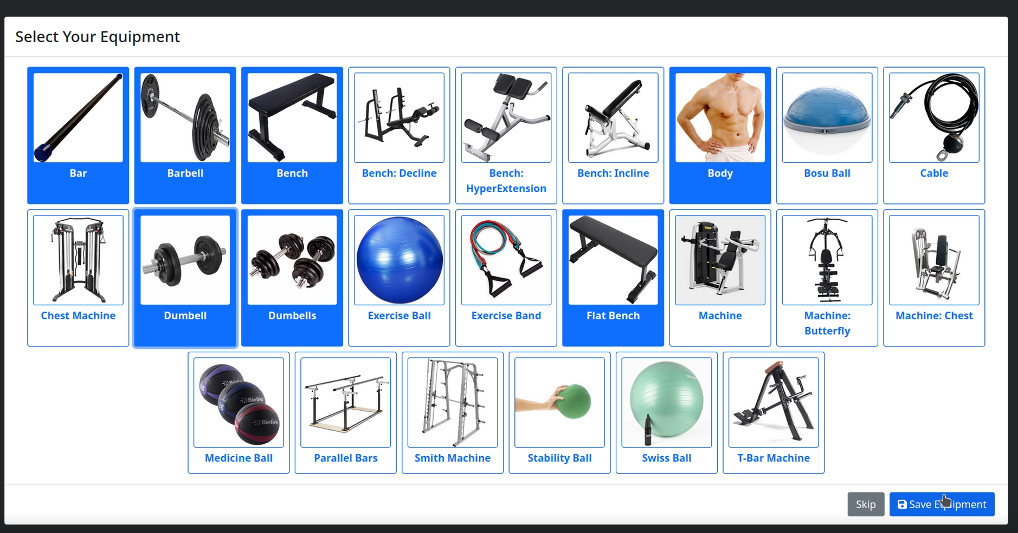

**6.5.1 Planner - Selecting Exercises to add (searching by filter)**

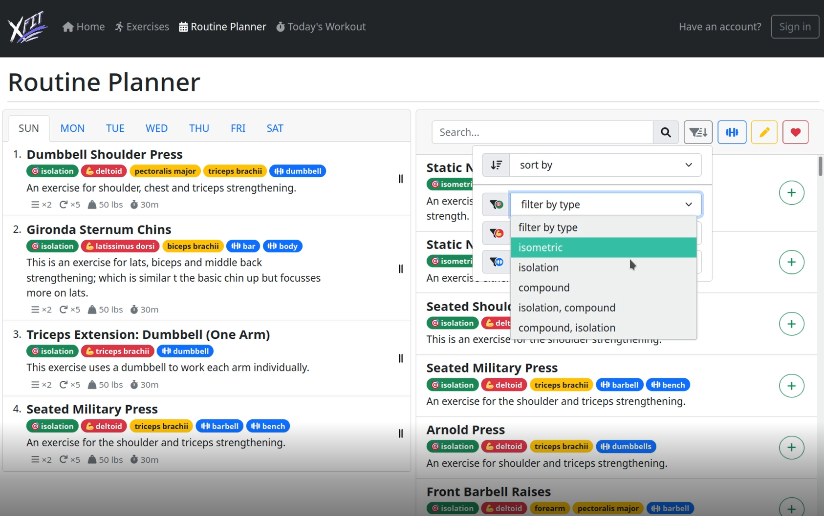

**6.5.2 Planner - Selecting Exercises to add.**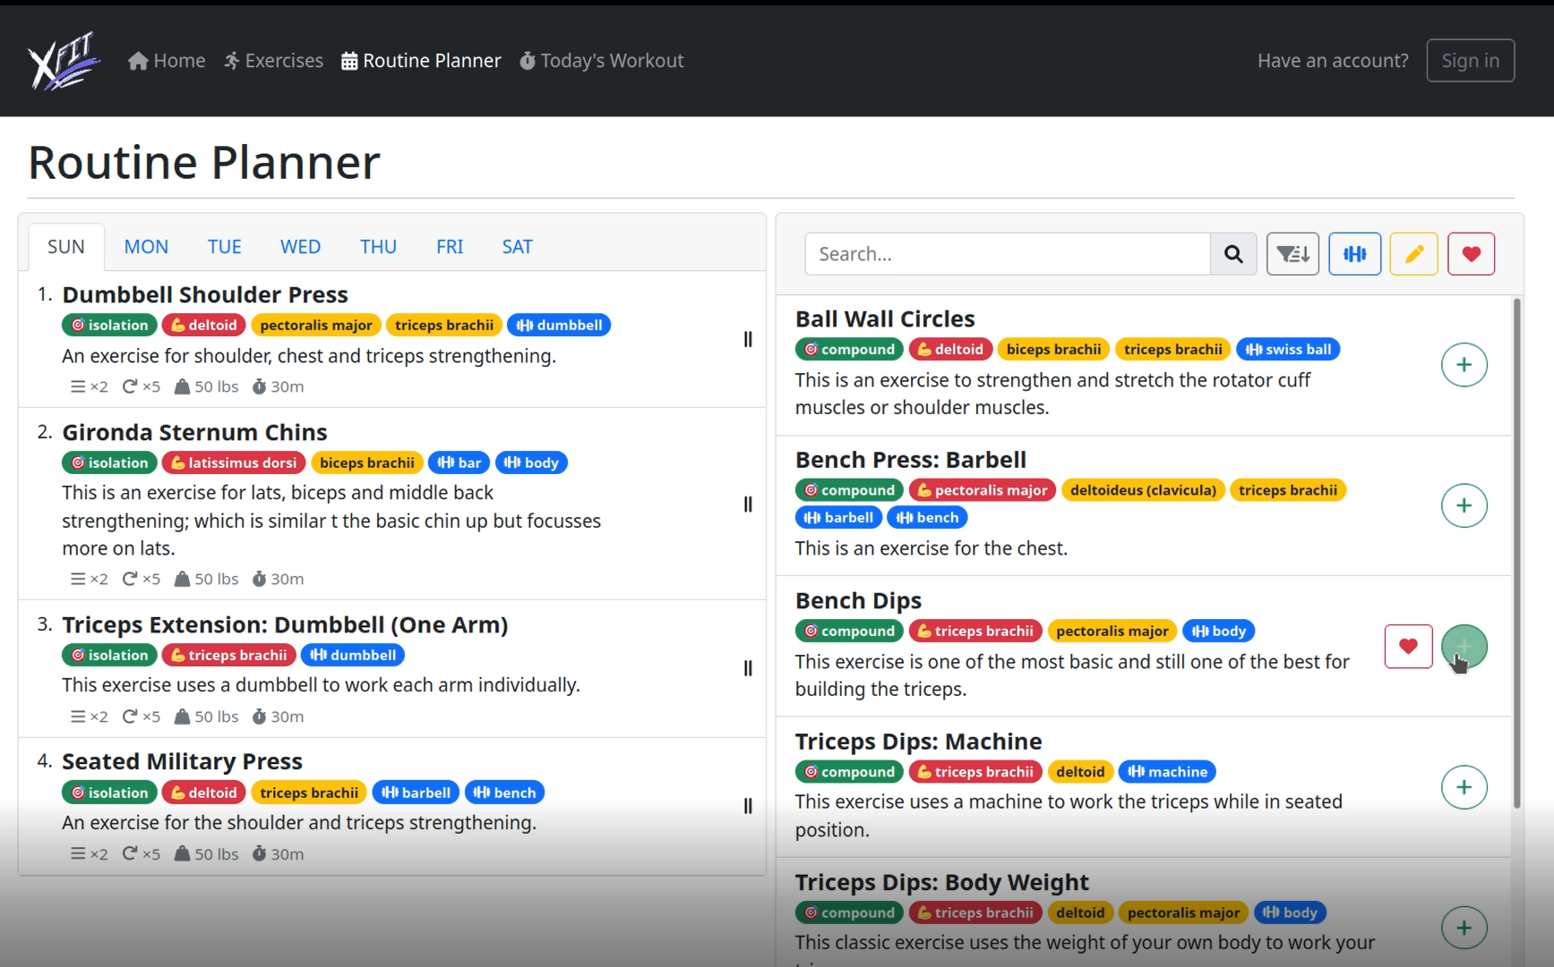

**6.5.2 Planner - Editing when adding to the planner**

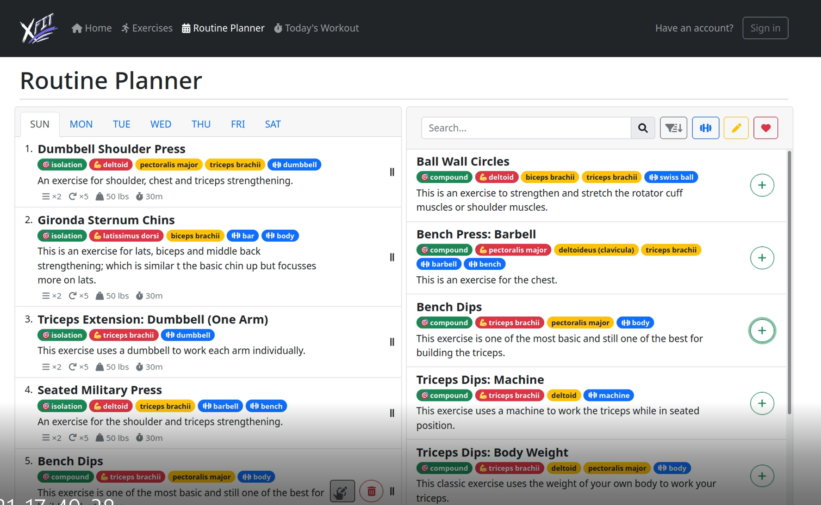

**6.5.3 Planner - Editing exercise specifications when adding to Routine Day**

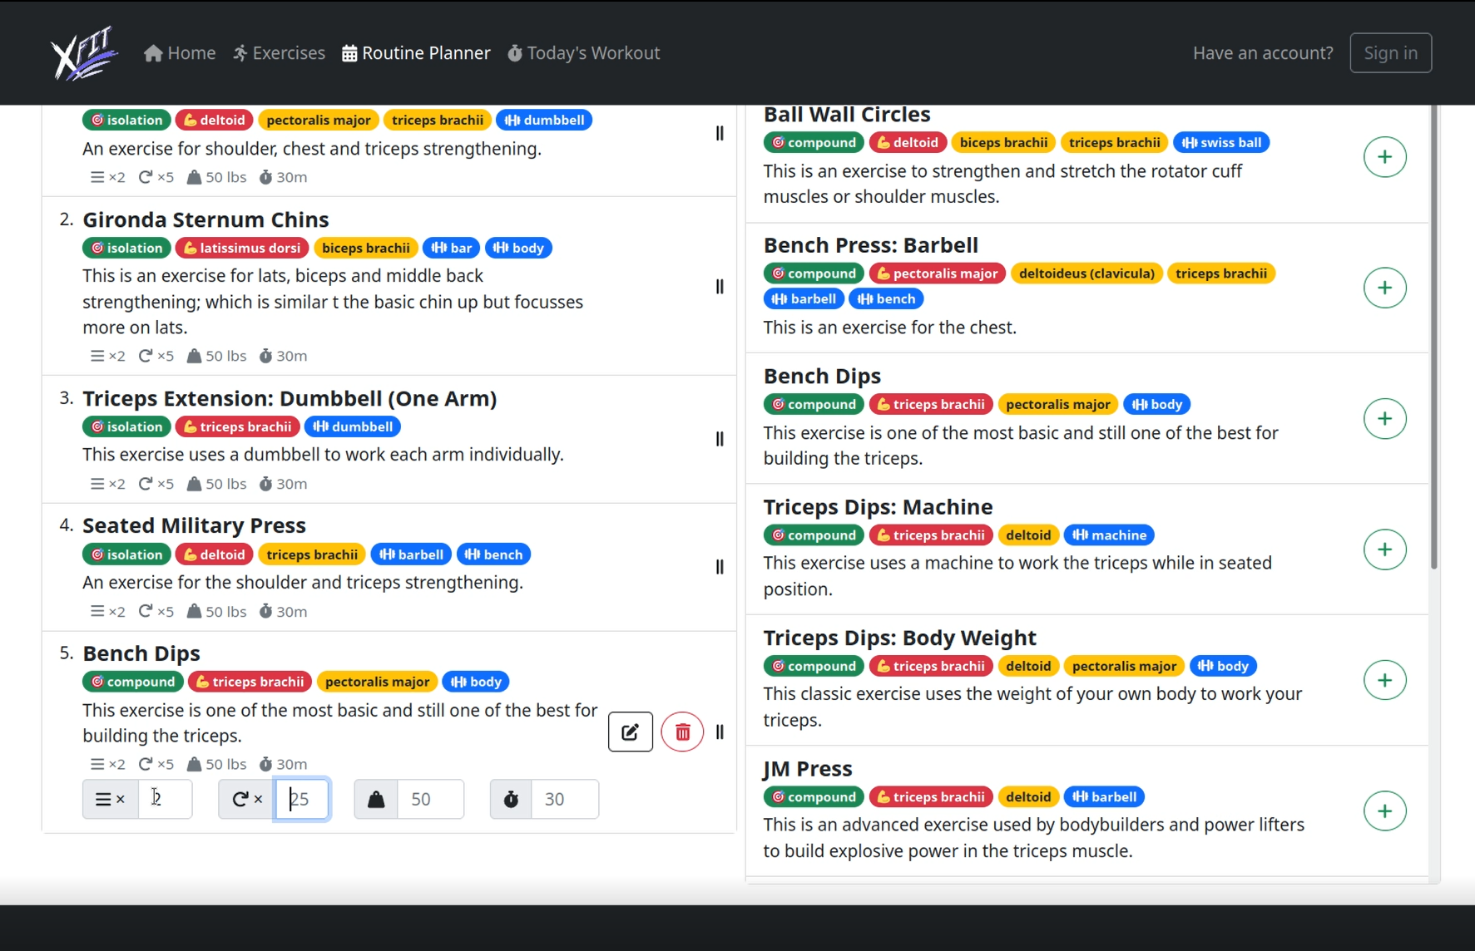

## 6.3 Screen Objects and Actions

NavBar buttons:

These include the planner, today's workout, exercises, sign in or account options at the top of most pages that redirect users to the appropriate pages.

Page body buttons:

These include buttons such as save changes in the bottom of the planner to save a routine. These include options on exercises in a list to either add them as favorites, delete them from a routine, add them to a routine, or to edit or delete a custom exercise. These also include the filtering options in an exercise list page.

Exercise entities:

These are the exercises that are listed based on user filtering options. These exercises can be ordered in a list, selected to view extra details of each given exercise, configured with specific reps and cycles as part of a plan, and edited if it's a user custom exercise.

Equipment entities:

These are the equipment a user can select to add them to their collection of owned equipment which is used for additional filtering options.

Input number boxes:

These include the verification code for email confirmation and the rep and cycles options for a planned exercise.

Input Password boxes:

This is used for when the user signs in or when they are creating a new account to hide the user input. These are coupled with a password strength meter to let users know the strength of their password.

Input email boxes:

These are used when a user enters an email from the sign in, registration, and verification pages. It is used to ensure a user inputs a text in the format of an email with an @ symbol.

Input text boxes:

These are used during registration for the users username and during the creation and editing of a custom exercise where users will type a title and a description for it.

Images:

Equipment and exercises have their own images loaded from the database. Each image has its own defined url.

### 

# 7. Detailed System Design

## 7.1 Data Structures

The primary data type used in this application are simple Lists. Each of the database classes returns a list of String names or a list of objects the database class represents to be passed into the controller which will pass it to the view for when a variety of that object needs to be displayed, such as the exercise list page for example.

Collections are used for most of the properties of our standard Java Bean classes. These collections are mainly used to store a list of objects for a given class that are associated with the id of another class. For example, the User property Collection<UserEquipment> UserEquipmentsById associates a collection of UserEquipment objects of the UserEquipment class associated with the User id property.

Maps are used in a few places in our design. One of the uses for maps are when a list of plans are mapped to one of the 7 days of the week used in the User property Map<String, List<Plan>> planListByDayMap.

## 7.2 Exercise/ ExerciseDB Entity

### 7.2.1 Responsibilities

This Exercise class is responsible for creating Exercise objects with attributes based on the Domain Object in the database it is meant to represent.

The ExerciseDB class here is responsible for creating Database queries for fetching exercises based on name or on exercises based on a muscle type. It is also responsible for gathering data from other beans using its collections.

### 7.2.2 Uses/Interactions

This component is primarily used by:

* Exercise Controller (Servlet): The servlet interacts with this component to retrieve, update and delete exercises from the exercise table.
* Plan Controller (Servlet): The servlet interacts with this component by using it to select an exercise from the database based on name that the user has selected from the routine planner

### 7.2.3 Constraints

* Exercise class must be declared an entity with entity manager
* Must have pre-established and defined namedQueries for DB methods to utilize with EntityManager.
* Each DB method must utilize an entity manager to establish connection to the database for named queries.
* Attribute Constraints:
* Int ID cannot be null and is a generated value for identification and must be unique
* String name cannot be null and max length is 256 characters and must be unique
* String title cannot be null and max length is 256 characters
* String primer max length is 512 characters
* String type max length is 32 characters
* User userByUserId many reference column name “id” with int user id with a many to one
* Collection<ExerciseEquipment> exerciseEquipmentById is mapped to an exercise ID by a one to many
* Collection<ExerciseImage> exerciseImagesById is mapped to an Exercise ID one to many
* Collection<ExerciseMuscle> exerciseMusclesById is mapped to an Exercise ID one to many
* Collection<FavoriteExercise> favoriteExercisesById is mapped to an Exercise ID one to many
* Collection<Plan> plansById is mapped to an Exercise ID one to many

### 7.2.4 Composition

| **Attribute** | **Description** |
| --- | --- |
| Id: int | Used to store identification number of primary key of exercise |
| Name: String | Used to store name of exercise for identification |
| Title: String | Used to store name of exercise as displayed to users |
| Primer: String | Used to store exercise description for users |
| Type: String | Used to store whether exercise works out multiple muscles |
| Steps: String | Used to store the steps on completion for the given exercise |
| Tips: String | Used to store additional information on proper completion for the given exercise |
| Links: String | Used to store any external links to additional guidance for users |
| userByUserId: User | Used to store the user object associated with exercise. |
| exerciseEquipmentsById: Collection<ExerciseEquipment> | Used to store a list of equipment associated with the exercise ID of the given exercise |
| ExerciseImagesById: Collection<ExerciseImage> | Used to store the associated images for this exercise through the given exercise ID using the Exercise Image object joining the exercise with the image |
| ExerciseMusclesById: Collection<ExerciseMuscle> | Used to store the associated muscle objects for this exercise that are involved in the exercise process using the Exercise Muscle object joining the exercise with the muscle |
| favoriteExercisesById: Collection<FavoriteExercise> | Used to store which users this exercise has been favorited by. |
| PlansById: Collection<Plan> | Used to store which routine plans this exercise is involved in. |
| Int BATCH_SIZE | Used to store final batch size this component will used to define the amount of changes made to the database at once |

| **Method** | **Description** |
| --- | --- |
| Exercise() | Default Constructor |
| Boolean equals(Object o) | Returns true if object o is equal to current object through its hashcode or through its attributes. Returns false if o is null or if o does not equal the current object. |
| int hashCode() | Returns the hashcode of the exercise object by hashing all its attributes into an array |
| int getId() | Return the int Id |
| void setId(int id) | Set the current id to a new one |
| Integer getUserId() | Return the integer userId. |
| void setUserId(Integer userId) | Set the current userId to a new one. |
| String getName() | Return the string name |
| void setName(String name) | Set the current name to a new one |
| String getTitle() | Return the String title |
| void setTitle(String title) | Set the current title to a new one |
| String getPrimer() | Return the string primer |
| void setPrimer(String primer) | Set the current primer to a new one |
| String getType() | Return the string type |
| void setType(String type) | Set the current type to a new one |
| String getSteps() | Return the String steps |
| void setSteps(String steps) | Set the current steps to a new one |
| String getTips() | Return the String tips |
| void setTips(String tips) | Set the current tips to a new one |
| String getLinks() | Return the String links |
| void setLinks(String links) | Set the current links to a new one |
| User getUserByUserId() | Returns the user object associated with the given exercise |
| void setUserByUserId(User userByUserId) | Sets the user object associated with the given exercise to a new one |
| Collection<ExerciseEquipment> getExerciseEquipmentsById() | Return the collection of exercise equipments |
| void setExerciseEquipmentsById(Collection<ExerciseEquipment> exerciseEquipmentsById) | Set the collection of exercise equipments to a new one |
| Collection<ExerciseImage> getExerciseImagesById() | Return the collection of ExerciseImages |
| void setExerciseImagesById(Collection<ExerciseImage> exerciseImagesById) | Set the collection of ExerciseImages to a new one |
| Collection<ExerciseMuscle> getExerciseMusclesById() | Return the collection of ExerciseMuscles |
| void setExerciseMusclesById(Collection<ExerciseMuscle> exerciseMusclesById) | Set the collection of ExerciseMuscles to a new one |
| Collection<FavoriteExercise> getFavoriteExercisesById() | Return the collection of Users who favorited the given exercise |
| void setFavoriteExercisesById(Collection<FavoriteExercise> favoriteExercisesById) | Set the collection of Users who favorited the given exercise to a new one |
| Collection<Plan> getPlansById() | Return the collection of Plans containing the given exercise |
| void setPlansById(Collection<Plan> plansById) | Set the collection of Plans containing the given exercise to a new one |
| Collection<Muscle> getMuscles(boolean isSecondary) | Return the collection of muscles used by the given exercise. If parameter is true, returns the list of secondary muscles and returns primary ones if false |
| Collection<Muscle> getPrimaryMuscles() | Calls method getMuscles for isSecondary false |
| Collection<Muscle> getSecondaryMuscles() | Calls method getMuscles for isSecondary true |
| Collection<String> getStepsList() | Returns a listed format of the steps by converting attribute steps to a list |
| Collection<String> getTipsList() | Returns a listed format of the tips by converting attribute tips to a list |
| List<Exercise> selectAll() | Creates an entitymanager object for establishing database connection. Uses namedQuery to receive the list of all exercises from the “Exercise” table in the database and return it as a list |
| List<Exercise> selectAllAvaliableTo(User user) | Creates an entitymanager object to utilize a predefined named Query to return a list of exercises that are available for a given user which includes all of our provided exercises or exercises created by the user |
| Exercise selectByName(String name) | Creates an entitymanager object for establishing database connection. Uses namedQuery to receive a single exercise from the “Exercise” table in the database based on its name that matches the String name in the parameter and return it as an exercise object |
| Boolean hasExerciseByName(String exercise) | Uses the selectByName method to determine if a given exercise already exists in the database |
| List<String> fetchTypesList() | Creates an entitymanager object for establishing database connection. Uses namedQuery to receive the types from all exercises in the table “Exercise” and returns it as a list. |
| Void insert(Exercise exercise) | Inserts an exercise object into the database using its defined attribute columns as values to match the table. Will throw a general exception if the exercise is failed to insert |
| Void deleteByName(String exercise) | Uses the selectByName method to select an exercise from the database and use entitymanager to remove it. Throws a general exception if deletion could not process |
| String makeUniqueName(String userName, String exerciseTitle) | Generates a new name identifier for a custom exercise created by the user. |

### 7.2.5 Resources

The primary resource used for this component is the Exercise table from the database. Other sources from other database tables are specified by the mapping that this component associates with.

### 7.2.6 Processing

**Public static Exercise selectByName(String name)**

1. Using entityManager creates an Entity Manager by calling DB Util class.
2. Create a typedquery with type Exercise
3. TypedQuery selects Exercise by Name from the Exercise table using the exercise class name.
4. Set Parameter in the typedQuery to the name of the exercise to select.
5. Initialize an exercise object named result and set it as null.
6. Declare a try block
   1. Set result equal to the query result if any
7. Declare a catch block
   1. catching an exception for no result and displaying an “Exercise Not Found” message.
8. Returning result.

**Public static List<Exercise> selectAll()**

1. By initializing entity manager to null.
2. By initializing resultList to null a List of type Exercise.
3. Create a try block
   1. Set the entity manager equal to the DBUtil.createEnitityManager()
   2. Create a query based off of the NamedQuery specified in the Exercise class called selectAll
4. Set the resultList equal to the result of the query using DBUtil.castList()
5. Create a catch block
   1. print the line for error if caught.
6. Returning resultList.

**Public Static List<String> fetchTypesList()**

1. Having type List of Strings and a method to fetch types.
2. Initialize an entitymanager and resultsList and set it to null.
3. Create a try block
   1. creating an entity manager with DBUtil.getEntityManagerFactory()
   2. creating a query for exercise to select Distinct Types using the nameQuery defined in the exercise class “SelectDistinctTypes”
   3. fetchTypesList uses a query that gets the ResultList and it is placed in the same List using DBUtil.castList()
4. Create a catch block
   1. It can catch a Noresult Exception and if caught it will show a system error message.
5. Lastly it returns a list of results.

**Public static boolean hasExerciseByName(String exercise)**

1. Set a boolean success to false
2. Create an exercise object named myExercise using the result of the selectExercise(exercise) method
3. If the myexercise object is set success to true
4. Return success

**public static void deleteByName(String name)**

1. Create a entity manager using the DBUtil.getEntityManagerFactory()
2. Begin the connection of the entitymanager
3. Create a try block
   1. Create exercise object 1 equal to the result of selectByName(name)
   2. Create exercise object 2 equal to the query result using the exercise id of object 1
   3. Using entity remove, delete the database entry matching object 2 and commit it
4. Create a catch block
   1. Print error message if the deletion went wrong due to nonexistent exercise in the database
5. Create a finally block
   1. Close the connection with entity manager at the end

**Public static List<Exercise> selectAllAvaliableTo(User user)**

1. Create an empty list of exercises object and entity manager object
2. Declare a try block
   1. Set the entity manager equal to DBUtil.getEntityManagerFactory()
   2. Create a query object set equal to the namedQuery defined in the Exercise component “SelectAllAvaliable”
   3. Set the query parameter to match userByUserId column ID with the User object passed as a parameter
   4. Use DBUtil.CastList() to return a list of all exercises either null or with an ID matching the user ID
3. Declare a catch block
   1. Print the error message if a NoResultException is caught
4. Return the result list from the query

**Public static String makeUniqueName(String userName, String exerciseTitle)**

1. Define a placeholder string name
2. Create a string builder object to filter out any special characters of the userName and exerciseTitle parameter and add dashes in place of spaces
3. Set string name equal to the toString() of the string builder object
4. While the identifier string name is a unique string among the other name identifiers in the exercise table in the database, generate a random Base64 String id that is 6 bytes long and set it equal to a String id. Using a new String builder object, set string name equal to the String Builder object that appends the generated toString() id to it
5. Return the String name which is the unique name identifier for a custom exercise

## 7.3 Muscle / MuscleDB Entity

### 7.3.1 Responsibilities

This Muscle class is responsible for creating Muscle objects with attributes based on the Domain Object in the database it is meant to represent.

The MuscleDB class here is responsible for creating a Database query for fetching all muscles in the table. It is also responsible for gathering data from other beans using its collections.

### 7.3.2 Uses/Interactions

This component is used only by the Exercise Controller servlet. It includes the types of muscles that are used for a given exercise when it is passed into the request.

### 7.3.3 Constraints

* Muscle Class must be declared an entity with entity manager
* Must have pre-established and defined namedQueries for DB methods to utilize with EntityManager.
* Each DB method must utilize an entity manager to establish connection to the database for named queries.
* Attribute Constraints:
* Int ID cannot be null and is a generated value for identification and must be unique
* String name cannot be null and must be unique with a max length of 32
* Collection<ExerciseMuscle> exerciseMuscleById must be mapped to a Muscle ID by one to many

### 7.3.4 Composition

| **Attribute** | **Description** |
| --- | --- |
| Id: int | Used to store identification number of primary key of a given muscle |
| Name: String | Used to store the identification name of a given exercise |
| exerciseMusclesById: Collection<ExerciseMuscle> | Used to store a list of exercise-muscle objects based on what muscles are used by a given exercise. Exercise muscle objects establish a join between an exercise and a muscle that the exercise uses |

| **Method** | **Description** |
| --- | --- |
| Muscle() | Default constructor |
| Boolean equals(Object o) | Returns true if object o is equal to current object through its hashcode or through its attributes. Returns false if o is null or if o does not equal the current object. |
| Int hashCode() | Returns the hashcode of the muscle object by hashing all its attributes into an array |
| Int getId() | Return the int Id |
| Int setId(int id) | Set the current id to a new one |
| String getName() | Return the String name |
| Void setName(String name) | Set the current name to a new one |
| Collection<ExerciseMuscle> getExerciseMusclesById() | Return the collection of ExerciseMuscle objects |
| Void setExerciseMuscleById(Collection<ExerciseMuscle> exerciseMusclesById) | Set the collection of ExerciseMuscle Objects to a new one |
| List<Muscle> selectAll() | Creates an entitymanager object for establishing database connection. Utilizes the namedQuery to receive all of the muscles in the Muscle table in the database and returns it as a list |
| List<String> fetchNamesList() | Calls the selectAll() method of the MuscleDB class to receive a list of all muscles in the database but then map each muscle to a name with a stream and return this mapping as a list. |

### 7.3.5 Resources

The primary resource used for this component is the Muscle table from the database. Other sources from other database tables are specified by the mapping that this component associates with such as the ExerciseMuscle bean class.

### 7.3.6 Processing

**Public static List<Muscle> selectAll()**

1. The selectAll method starts by creating a List of type Muscle that is public and the selectAll method can be accessed by other classes.
2. By using entity manager the DBUtil gets the entityManagerFactory and places it in an entity manager.
3. It then creates a NamedQuery to select AllMuscles based off of the named query specified in the Muscle Class.
4. By using DBUtil creates a list of type Muscles and stores a resultsList with what it gets from the List query to the Muscle class.
5. It returns a list of all muscles.

**Public static** **List<String> fetchNamesList()**

1. This method creates a type string List of fetchNames. The muscles that are fetched by a name and return muscles mapped by name and places them in a list.
2. It returns a MuscleDB and two methods that return all of the muscles and   
   a) maps it to a Muscle by getting the name.

b) collects to a List .

## 7.4 Image Entity

### 7.4.1 Responsibilities

This Image class is responsible for creating image objects with attributes based on the Domain Object in the database it is meant to represent. It is also responsible for gathering data from other beans using its collections. It's to be used by other classes to load image data from the database.

### 7.4.2 Uses/Interactions

This entity is used by the image servlet.

### 7.4.3 Constraints

* Image class must be declared an entity with entity manager
* Attribute Constraints:
* Int ID cannot be null and is a generated value for identification and must be unique
* Collection<ExerciseImage> exerciseImagesById must be mapped to a ImageID by one to many
* Collection<EquipmentImage> equipmentImagesById must be mapped to a ImageID by one to many

### 7.4.4 Composition

| **Attribute** | **Description** |
| --- | --- |
| Int: id | Used to store identification of given image from database |
| Byte[]: image | Used to store the image data converted into a byte array |
| Collection<ExerciseImage>: exerciseImagesById | Used to store the exercises utilizing this image class using the joint bean class ExerciseImage to associate a exercise with images by the Image ID |
| Collection<EquipmentImage>: equipmentImagesById | Used to store the equipments utilizing this image class using the joint bean class EquipmentImage to associate an equipment with an image by the Image ID |

| **Method** | **Description** |
| --- | --- |
| Image() | Default constructor |
| Boolean equals(object o) | Returns true if object o is equal to current object through its hashcode or through its attributes. Returns false if o is null or if o does not equal the current object. |
| Int hashCode() | Returns the hashcode of the image object by hashing all its attributes into an array |
| Int getId() | Return the int Id |
| Void setId(int id) | Sets the current to a new one |
| Byte[] getImage() | Return the byte array data of the image |
| Void setImage(byte[] image) | Sets the current byte array data to a new one |
| Collection<ExerciseImage> getExerciseImagesById() | Return the collection of ExerciseImage objects used by the given Image |
| Void setExerciseImagesById(Collection<ExerciseImage> exerciseImagesById) | Sets the collection of ExerciseImage objects to a new one |
| Collection<EquipmentImage> getEquipmentImagesById() | Return the collection of EquipmentImage objects used by the given Image |
| Void setEquipmentImagesById(Collection<EquipmentImage> equipmentImagesById) | Sets the collection of EquipmentImage objects to a new one |

### 7.4.5 Resources

The primary table utilized by this component is the Image table from the database. Communications with the join table ExerciseImage are used to associate which Images are used by certain exercises.

### 7.4.6 Processing

The processing for this class is described in other components that utilize this component.

## 

## 7.5 ExerciseImage Entity

### 7.5.1 Responsibilities

This class is responsible for joining the Exercise and Image components to represent the joint table between the two tables in the database. It maps images to exercises based off of their Id’s and combines their id’s to a key class used to represent a primary key based off of the composite keys with an embedded id. This component is used to map what exercises use what specific images for guidance.

### 7.5.2 Uses/Interactions

This component utilizes the ExerciseImageKey class to establish a central primary key using the two composite keys from exerciseId and ImageId. This component is used by the Exercise and Image components to establish a join between them.

### 7.5.3 Constraints

* ExerciseImage class must be declared an entity with entity manager
* Attribute Constraints:
* String exerciseState must not be null and the length must be a max 32
* Exercise exerciseByExerciseId must not be null and must reference the attribute id of this class. Must map to exerciseId with a many to one relation
* Image imageByImageId must not be null and must reference the attribute id of this class. Must map to imageId with a many to one relation

### 7.5.4 Composition

| **Attribute** | **Description** |
| --- | --- |
| ExerciseImagePK: id | Used to store the embedded key id representing the combined primary key of this class |
| String: exerciseState | Used to store the state of the exercise image whether its a tension or relaxation picture of the given exercise |
| Exercise: exerciseByExerciseId | Used to store the exercise joined within this bean to match to an image by its id |
| Image: imageByImageId | Used to store the image joined within this bean to match to an exercise by its id |
| **ExerciseImagePK class** | Has its own respective int exercise id and int image id attributes |

| **Method** | **Description** |
| --- | --- |
| ExerciseImage() | Default constructor |
| Boolean equals(Object o) | Returns true if object o is equal to current object through its hashcode or through its attributes. Returns false if o is null or if o does not equal the current object. |
| Int hashCode() | Returns the hashcode of the ExerciseImage object by hashing all its attributes into an array |
| ExerciseImagePK getId() | Returns the embedded key id |
| Void setId(ExerciseImagePk id) | Sets the embedded key id to a new one |
| String getExerciseState() | Return the string exercise state |
| Void setExerciseState(String exerciseState) | Sets the old String exercise state to a new one |
| Exercise getExerciseByExerciseId() | Return the given exercise object used in this bean class |
| Void setExerciseByExerciseId(Exercise exerciseByExerciseId) | Sets the given exercise object used in this bean class to a new one |
| Image getImageByImageId() | Return the given image object used in this bean class |
| void setImageByImageId(Image imageByImageId) | Sets the given image object used in this bean class to a new one |
| **ExerciseImagePK** | Has its own respective constructor, equals and hashcode function, and it getters and setters for an exercise id an image id |

### 7.5.5 Resources

This component uses data from its corresponding ExerciseImage table in the database. This component also uses the exercise id and image id from their respective tables to associate the id to an exercise and image object respectively.

### 7.5.6 Processing

This component on its own does not do any major processing.

## 

## 7.6 ExerciseMuscle Entity

### 7.6.1 Responsibilities

This class is responsible for joining the Exercise and Muscle components to represent the joint table between the two tables in the database. It maps muscles to exercises based off of their Id’s and combines their id’s to a key class used to represent a primary key based off of the composite keys with an embedded id. This component represents what exercises work on what specific muscles.

### 7.6.2 Uses/Interactions

This component utilizes the ExerciseMuscleKey class to establish a central primary key using the two composite keys from exerciseId and MuscleId. Used to establish the join between the Exercise and Muscle tables.

### 7.6.3 Constraints

* ExerciseMuscle class must be declared an entity with entity manager
* Attribute Constraints:
* ExerciseMuscleKey id must be the only embedded Id to denote the composite primary key
* Int IsSecondary cannot be null
* Exercise exerciseByExerciseId must not be null and must reference the attribute id of this class. Must map to exerciseId with a many to one relation
* Muscle muscleByMuscleId must not be null and must reference the attribute id of this class. Must map to muscleId with a many to one relation

### 7.6.4 Composition

| **Attribute** | **Description** |
| --- | --- |
| ExerciseMusclePK: id | Used to store the embedded key representing the combined primary keys of this class |
| int: isSecondary | Used to store the int value to determine whether the given exercise is associated with a secondary muscle or not |
| Exercise: exerciseByExerciseId | Used to store the exercise joined within this bean to match to an muscle by its id |
| Muscle: muscleByMuscleId | Used to store the muscle joined within this bean to match to an exercise by its id |
| **ExerciseMusclePK** | Has its own respective int exercise id and int muscle id attributes |

| **Method** | **Description** |
| --- | --- |
| ExerciseMuscle() | Default constructor |
| Boolean equals(Object o) | Returns true if object o is equal to current object through its hashcode or through its attributes. Returns false if o is null or if o does not equal the current object. |
| int hashCode() | Returns the hashcode of the ExerciseMuscle object by hashing all its attributes into an array |
| ExerciseMusclePK getId() | Returns the embedded key id |
| void setExerciseId(int exerciseId) | Sets the embedded key id to a new one |
| int getIsSecondary() | Returns the int value representing whether the given muscle is a secondary muscle or not |
| void setIsSecondary(int isSecondary) | Sets the old isSecondary attribute to a new int |
| Exercise getExerciseByExerciseId() | Returns the given exercise object currently mapped to a muscle in this bean |
| void setExerciseByExerciseId(Exercise exerciseByExerciseId) | Sets the given exercise object currently mapped to a muscle in this bean to a new one |
| Muscle getMuscleByMuscleId() | Returns the given muscle object currently mapped to a exercise in this bean |
| void setMuscleByMuscleId(Muscle muscleByMuscleId) | Sets the given muscle object currently mapped to a exercise in this bean to a new one |
| **ExerciseMusclePK** | Has its own respective constructor, equals and hashcode function, and it getters and setters for an exercise id an muscle id |

### 7.6.5 Resources

This component uses data from its corresponding ExerciseMuscle table in the database. This component also uses the exercise id and muscle id from their respective tables to associate the id to an exercise and muscle object respectively.

### 7.6.6 Processing

This component on its own has no major processing.

# 

## 7.7 FavoriteExercise Entity

### 7.7.1 Responsibilities

This class is responsible for joining the User and exercise components to represent the joint table between the two tables in the database. It maps users to exercises based off of their Id’s and combines their id’s to a key class used to represent a primary key based off of the composite keys with an embedded id. This component represents what exercises are favored by what users.

### 7.7.2 Uses/Interactions

This component utilizes the FavoriteExerciseKey class to establish a central primary key using the two composite keys from userId and exerciseId. Used by the User and Exercise tables to establish a join between them.

### 7.7.3 Constraints

* FavoriteExercise class must be declared an entity with entity manager
* The PrimaryKey of this class must be assigned to FavoriteExercisePK with Id class
* Attribute Constraints:
* User userByUserId must not be null and must reference the attribute id of this class. Must map to userId with a many to one relation with a fetch type of LAZY
* Exercise exerciseByexerciseId must not be null and must reference the attribute id of this class. Must map to exerciseId with a many to one relation with a fetch type of LAZY

### 7.7.4 Composition

| **Attribute** | **Description** |
| --- | --- |
| FavoriteExercisePK: id | Used to store the embedded key representing the combined primary of this class |
| User: userByUserId | Used to store the user object joined within this entity by its user id |
| Exercise: exerciseByExerciseId | Used to store the exercise object joined within this entity by its exercise id |
| **FavoriteExercisePK** | Contains its own attributes of a int user id and int exercise id that is placed in the PK component to identify it with a single key |

| **Method** | **Description** |
| --- | --- |
| Boolean equals(Object o) | Returns true if object o is equal to current object through its hashcode or through its attributes. Returns false if o is null or if o does not equal the current object. |
| Public FavoriteExercise(User userByUserId, Exercise exerciseByExerciseById) | Constructor used by the user class to create a new associate between a user and a favorited exercise |
| Int hashCode() | Returns the hashcode of the favoriteExercise object by adding its attributes together and multiplying them with the hash number |
| FavoriteExercisePK getId() | Returns the embedded key id |
| Void setId(FavoriteExercisePK id) | Sets the embedded key id to a new one |
| User getUserByUserId() | Returns the user object matched to a user id |
| Void setUserByUserId(User userByUserId) | Sets the old user object to a new one |
| Exercise getExerciseByExerciseId() | Returns the exercise object matched to an exercise id |
| Void setExerciseByExerciseId(Exercise exerciseByExerciseId) | Sets the old exercise object to a new one |
| **FavoriteExercisePK** | This component has its own boolean equals, Int hash code, and getter and Setter methods for int user id and int exercise id |

### 7.7.5 Resources

This component uses data from its corresponding favoriteExercise table in the database. This component also uses the user id and exercise id from their respective tables to associate the id to an user and exercise object respectively to represent a user favoriting an exercise.

### 7.7.6 Processing

This component alone does not do any major processing.

## 

## 7.8 Equipment / EquipmentDB class

### 7.8.1 Responsibilities

This Equipment class is responsible for creating Equipment objects with attributes based on the Domain Object in the database it is meant to represent.

The EquipmentDB class here is responsible for creating Database queries for fetching all equipment objects and for fetching the list of all names of equipment from the database. It is also responsible for gathering data from other beans using its collections.

### 7.8.2 Uses/Interactions

This component is used by:

User Controller (servlet): Used by this component to configure what equipments are owned by a given user and when a user adds an equipment to their profile

Equipment Controller (servlet): Gathers the list of all the equipments from the equipment table in the database and sends it to the request

Exercise Controller (servlet): Used to associate gather the equipments names list when associated with an exercise

### 7.8.3 Constraints

* Equipment class must be declared an entity with entity manager
* Must have pre-established and defined namedQueries for DB methods to utilize with EntityManager.
* Each DB method must utilize an entity manager to establish connection to the database for named queries.
* Attribute Constraints:
* Int ID cannot be null and is a generated value for identification and must be unique
* String name cannot be null and max length is 32 characters
* Collection<EquipmentImage> equipmentImagesById is mapped to an Equipment ID one to many with equipmentImage objects
* Collection<ExerciseEquipment> exerciseEquipmentById is mapped to an Equipment id by one to many with exerciseEquipment objects
* Collection<UserEquipment> userEquipmentsById is mapped to an Equipment Id by one to many UserEquipment objects

### 7.8.4 Composition

| **Attribute** | **Description** |
| --- | --- |
| Int: id | Used to store the identification number of the primary key of the Equipment |
| String: Name | Used to store the name of the given equipment |
| Collection<EquipmentImage>: equipmentImagesById | Used to store the equipment image objects associated with the given equipment id |
| Collection<ExerciseEquipment> exerciseEquipmentsById | Used to store the exercise equipment objects associated with the given equipment id |
| Collection<UserEquipment> userEquipmentsById | Used to store the user equipment objects associated with the given equipment id |

| **Method** | **Description** |
| --- | --- |
| Equipment() | Default Constructor |
| Boolean equals(Object o) | Returns true if object o is equal to current object through its hashcode or through its attributes. Returns false if o is null or if o does not equal the current object. |
| int hashCode() | Returns the hashcode of the Equipment object by hashing all its attributes into an array. Returns 0 if the name of the object happens to be null |
| int getId() | Returns the equipment id int |
| setId(int id) | Sets the new equipment int id to a new one |
| String getName() | Returns the string name of the equipment object |
| void setName(String name) | Sets the old string name of equipment to a new one |
| Collection<EquipmentImage> getEquipmentImagesById() | Returns the list of EquipmentImage objects associated with the equipment id |
| void setEquipmentImagesById(Collection<EquipmentImage> equipmentImagesById) | Sets the old list of EquipmentImage objects associated with the equipment id to a new one |
| Collection<ExerciseEquipment> getExerciseEquipmentsById() | Returns the list of ExerciseEquipment objects associated with the equipment id |
| void setExerciseEquipmentsById(Collection<ExerciseEquipment> exerciseEquipmentsById) | Sets the old list of ExerciseEquipment objects associated with the equipment id to a new one |
| Collection<UserEquipment> getUserEquipmentsById() | Returns the list of UserEquipment objects associated with the equipment id |
| void setUserEquipmentsById(Collection<UserEquipment> userEquipmentsById) | Sets the old list of UserEquipment objects associated with the equipment id to a new one |
| Boolean isUsedBy(User user) | Returns true if the a user object is found associated with an equipment class using the User parameter and using a stream method |
| List<Equipment> selectAll() | Uses entitymanager to create a query established by a named query in the Equipment class to return a list of all the equipments in the equipment table |
| List<String> fetchNamesList() | Fetches the names of all exercises in the table using the selectAll() method and mapping each to its getName() method to return a string |
| List<Equipment> selectByIdIn(List<Integer> id) | Uses entitymanager to unwrap a session class and use to create a MultiIdentifierLoadAccess object that will use the session to select an array of equipment objects based on the ids in the method parameter |
| Equipment selectById(int id) | Uses entitymanager to create a query established by a namedQuery in the Equipment class to return a Equipment object based on its id |

### 7.8.5 Resources

The primary resource used for this component is the Equipment table from the database. Other sources from other database tables are specified by the mapping that this component associates with including the UserEquipment, ExerciseEquipment, and EquipmentImage entities.

### 7.8.6 Processing

**Public boolean isUsedBy(User user)**

1. Return getUserEquipmentsById()
   1. Create a stream()
      1. Find anyMatch of a user using the equals(Object o) method
      2. Will find a user object that equals an equipment object indicating that a user is using this equipment

**Public static List<Equipment> selectAll()**

1. Create an entitymanager object using the DBUtil.getEntitymanagerFactory()
2. Create a query object using the namedQuery established in the equipment class “selectAll”
3. Create a List<Equipment> object named resultslist that will use the DBUtil.castList(Equipment.class, query) to return all equipment objects from the database using the equipment class as a template with the query
4. Return resultslist

**Public static List<String fetchNamesList()**

1. Uses the selectAll() method to create a stream and map all Equipments with their getName() methods to return a stream of strings
2. Convert the streams of strings to a list
3. Return the list

**Public static List<Equipment> selectByIdIn(List<Integer> ids)**

1. Create an entityManager object using DBUtil.getEntityManagerFactory()
2. Create a session object and set it equal to an unwrapped session class by entitymanager
3. Create a MultiIdentiferLoadAccess<Equipment> object named multiLoadAccess and set it equal to session.byMultipleIds(Equipment.class) which will return the attributes from the equipment class
4. Create a list<equipment> object named equipments and set it equal to the multiLoadAccess and using a multiload(ids) method, load all the equipment objects that have an Id within the List<integer> collection in the parameter
5. Return equipments

**Public static Equipment selectById(int id)**

1. Create an entityManager object using DBUtil.getEntityManagerFactory()
2. Create a typedquery object that will set itself equal to the namedQuery created in the equipment class “SelectById”
3. Set the parameters to the typedquery with the int id parameter
4. Create a null equipment object named result
5. Create a try block
   1. Set result equal to the result of the query which should return a equipment object using a matching id
6. Create a catch block
   1. Print the error message if a equipment object was not retrieved
7. Return result

## 

## 7.9 EquipmentImage Entity

### 7.9.1 Responsibilities

This class is responsible for joining the Equipment and images components to represent the joint table between the two tables in the database. It maps equipment to images based off of their Id’s and combines their id’s to a key class used to represent a primary key based off of the composite keys with an embedded id. This component represents what images belong to which equipment.

### 7.9.2 Uses/Interactions

This component utilizes the EquipmentImagePK class to establish a central primary key using the two composite keys from equipmentId and imageId. Uses the Equipment and Images components to establish a join between them.

### 7.9.3 Constraints

* EquipmentImage class must be declared an entity with entity manager
* The PrimaryKey of this class must be assigned to FavoriteExercisePK with Id class and will be referenced as “id”
* Attribute Constraints:
* Equipment EquipmentByEquipmentId must not be null and must reference the attribute id of this class. Must map to equipmentId with a many to one relation
* Image imageByImageId must not be null and must reference the attribute id of this class. Must map to imageid with with a many to one relation

### 7.9.4 Composition

| **Attribute** | **Description** |
| --- | --- |
| EquipmentImagePK: id | Used to store the embedded id that is meant to represent the combined primary key of this class |
| Equipment: equipmentByEquipmentId | Used to store the equipment object matching the id |
| Image: imageByimageId | Used to store the image object matching the id |
| **EquipmentImagePK** | Has its own int equipment id and int image id attributes |

| **Method** | **Description** |
| --- | --- |
| EquipmentImage() | Default Constructor |
| Boolean equals(Object o) | Returns true if object o is equal to current object through its hashcode or through its attributes. Returns false if o is null or if o does not equal the current object. |
| Int hashCode() | Returns the hashcode of the equipmentImage object by adding its attributes together and multiplying them with the hash number |
| EquipmentImagePK getId() | Returns the embedded id key |
| Void setId(EquipmentImagePK id) | Sets the int embedded id to a new one |
| Equipment getEquipmentByEquipmentId() | Returns the equipment object matched to a equipment id |
| Void setEquipmentByEquipmentId(Equipment equipmentByEquipmentId) | Sets the equipment object to a new one |
| Image getImageByImageId() | Returns the image object matched to a image id |
| Void setImageByImageId(Image imageByImageId) | Sets the image object to a new one |
| **EquipmentImagePK** | Has its own methods of a boolean equal, int hashcode and getters and setters for an int equipment id and int image id |

### 7.9.5 Resources

This component uses data from its corresponding EquipmentImage table in the database. This component also uses the image id and equipment id from their respective tables to associate the id to an equipment and image object respectively to represent what equipment uses what images.

### 7.9.6 Processing

This component alone does not perform any processing.

## 7.10 ExerciseEquipment Entity

### 7.10.1 Responsibilities

This class is responsible for joining the Exercise and equipment components to represent the joint table between the two tables in the database. It maps exercises to equipment based off of their Id’s and combines their id’s to a key class used to represent a primary key based off of the composite keys with an embedded id. This component represents what exercises use which equipment as part of the workout.

### 7.10.2 Uses/Interactions

This component utilizes the ExerciseEquipmentPK class to establish a central primary key using the two composite keys from exerciseId and equipmentId. Uses the exercise and equipment components to establish a join between them.

### 7.10.3 Constraints

* ExerciseEquipment class must be declared an entity with entity manager
* The PrimaryKey of this class must be assigned to ExerciseEquipmentPK with Id class and will be referenced as “id”
* Attribute Constraints:
* Equipment EquipmentByEquipmentId must not be null and must reference the attribute id of this class. Must map to equipmentId with a many to one relation
* Exercise ExerciseByExerciseId must not be null and must reference the attribute id of this class. Must map to exerciseid with with a many to one relation

### 7.10.4 Composition

| **Attribute** | **Description** |
| --- | --- |
| ExerciseEquipmentPK: Id | Used to store the embedded id that represents the combined primary key of this class |
| Equipment: equipmentByEquipmentId | Used to store the equipment object that is linked to int equipment id |
| **ExerciseEquipmentPK** | Has its own attributes for int exercise id and int equipment id |

| **Method** | **Description** |
| --- | --- |
| Boolean equals(Object o) | Returns true if object o is equal to current object through its hashcode or through its attributes. Returns false if o is null or if o does not equal the current object. |
| Int hashCode() | Returns the hashcode of the exerciseEquipment object by adding its attributes together and multiplying them with the hash number |
| ExerciseEquipmentPK getId() | Returns the object representing the embedded id |
| Void setId(ExerciseEquipmentPK id) | Sets the embedded id to a new one |
| Exercise getExerciseByExerciseId() | Returns the exercise object matching the int exercise id |
| Void setExerciseByExerciseId(Exercise exerciseByExerciseId) | Sets the exercise object to a new one |
| Equipment getEquipmentByEquipmentId() | Returns the equipment object matching the int equipment id |
| void setEquipmentByEquipmentId(Equipment equipmentByEquipmentId) | Sets the equipment object to a new one |
| **ExerciseEquipmentPK** | Has its own methods of a boolean equal, int hashcode and getters and setters for int exercise id and int equipment id |

### 7.10.5 Resources

This component uses data from its corresponding ExerciseEquipment table in the database. This component also uses the exercise id and equipment id from their respective tables to associate the id to an exercise and equipment object respectively to represent what equipment are used by what exercises.

### 7.10.6 Processing

This component alone does not perform any processing.

## 

## 7.11 Plan / PlanPK Entity

### 7.11.1 Responsibilities

This plan class is responsible for creating plan objects with attributes based on the Domain Object in the database it is meant to represent.

The PlanPK is meant to represent the embedded id class that combines the primary keys of the foreign tables that it uses.

### 7.11.2 Uses/Interactions

Uses the Exercise and User classes to connect to foreign tables for data collaboration. This component is also mainly used by the PlanController (servlet) to update, delete or insert a new plan specific to a user and to update a workout that is tied to a plan.

### 7.11.3 Constraints

* Plan Class must be declared an entity with entity manager
* Attribute Constraints:
* Byte dayOfWeek cannot be null
* Int position cannot be null
* Exercise exerciseByExerciseId must map to the exerciseid that is referenced in PlanPK with a many to one relation
* User userByUserId must map to the userid that is referenced in PlanPK with a many to one relation

### 7.11.4 Composition

| **Attribute** | **Description** |
| --- | --- |
| PlanPK: id | Used to store the embedded id that is used to combine the primary keys of the tables involved with this class |
| byte: dayOfWeek | Used to store which day of the week a given plan belongs to |
| Int: position | Used to store the position of a given exercise in the plan |
| Short: sets | Used to store the amount of sets to perform for an exercise |
| Short: reps | Used to store the amount of times an exercise is to be performed in a set |
| Short: weight | Used to store the given weight for the equipment used in a given exercise |
| Byte: isDone | Used to store whether a given exercise in the plan is selected as completed |
| User: userByUserId | Used to store the user object associated with the int user id from the PK |
| Exercise: exerciseByExerciseId | Used to store the exercise object associated with the int exercise id from the PK |
| **PlanPK** | Has its own int exercise id and int user id |

| **Method** | **Description** |
| --- | --- |
| Plan() | Default constructor |
| Boolean equals(Object o) | Returns true if object o is equal to current object through its hashcode or through its attributes. Returns false if o is null or if o does not equal the current object. |
| Int hashCode() | Returns the hashcode of the Plan object |
| PlanPK getId() | Returns the embedded id object |
| Void setId(PlakPK id) | Sets the embedded id object to a new one |
| Byte getDayofWeek() | Returns the byte representing the current day of the week |
| Void setDayOfWeek(byte dayOfWeek) | Sets the byte representing a day to a new one |
| Int getPosition() | Returns the position of a given exercise in the plan |
| Void setPosition(int position) | Sets the position of a exercise to a new one |
| Short setSets() | Returns the amount of sets used for a given exercise |
| Void setSets(Short sets) | Sets the amount of sets for a given exercise to a new one |
| Short getReps() | Returns the amount of reps used for a given exercise |
| Void setReps(Short reps) | Sets the amount of reps for a given exercise to a new one |
| Short getWeight() | Returns the weight of equipment for a given exercise |
| Void setWeight(Short weight) | Sets the weight of equipment for a exercise to a new one |
| Byte getIsDone() | Returns the value if a exercise is marked as completed by the user |
| Void setIsDone(Byte isDone) | Sets the value for if a exercise is completed to a new one |
| User getUserByUserId() | Returns the user object mapped to the user id in the PK |
| Void setUserByUserId(User userByUserId) | Sets the user object mapped to the PK to a new one |
| Exercise getExerciseByExercise() | Returns the exercise object mapped to the exercise id in the PK |
| Void setExerciseByExerciseId(Exercise exerciseByExerciseId) | Sets the exercise object mapped to the PK to a new one |
| **PlanPK** | Has its own boolean equals(), int hashcode, and getter and setters methods |

### 7.11.5 Resources

The primary resource used for this component is the Plan table from the database. Other sources from other database tables are specified by the mapping that this component associates with including the User and exercise entities.

### 7.11.6 Processing

This component alone does not perform any processing.

## 7.12 User / User DB entity

### 7.12.1 Responsibilities

This User class is responsible for creating user objects with attributes based on the Domain Object in the database it is meant to represent.

The UserDB class here is responsible for creating Database queries for fetching specific users identified by email and inserting new user objects into the user table in the database with the specified attributes upon registration.

### 7.12.2 Uses/Interactions

This component is used by:

User Controller (Servlet) - This servlet uses this component to create user entities that will be inserted into the user table upon registration/validation, or to use existing user entities from a query request for configuring the user account details the user email, password, username, and handling the equipment selection for a given user.

Exercise Controller (Servlet) - This servlet uses this component to list exercises that are available to a given user and to identify what custom exercises belong to what user upon configuration and creation of a custom exercise.

Plan Controller (Servlet) - This servlet uses this component to identify a user when they are using their planner to display and to show the specific work out for that planner for that given user. It also uses this component to identify a user when they are updating the planner and a workout linked to them.

### 7.12.3 Constraints

* User Class must be declared an entity with entity manager
* Each DB method must utilize an entity manager to establish connection to the database
* Must have pre-established and defined namedQueries for DB methods to utilize with EntityManager.
* Attribute Constraints:
* Int id cannot be null and must be a generated Identity type value made with javax.persistence
* String name cannot be null and the length can only be a max of 32 characters
* String email cannot be null and the length can only be a max of 64 characters
* String password cannot be null
* Collection<Exercise> exerciseById must map to userId that references the User column id by a one to many relations with a cascade type of ALL
* Collection<FavoriteExercises> favoritedExercisesById must map to a userId that references the User column id by a one to many with a cascade type of ALL
* Collection<Plan> plansById must map to user id that reference the User column id by a one to many relations with a cascade type of ALL
* Collection<UserEquipment> userEquipmentById must map to a user id the references the User column id by a one to many relation

### 7.12.4 Composition

| **Attribute** | **Description** |
| --- | --- |
| Id: int | Used to store the int id matched the user id in the table |
| String: name | Used to store user name of the user |
| String: email | Used to store the validated email of the given user |
| String: password | Used to store the hashed password of the user |
| String: accessToken | Used to store the access data that will be saved onto the client as a web cookie |
| Collection<Exercise> exercisesById | Used to store exercise objects associated with the given user id as it is mapped to |
| Collection<FavoriteExercise> favoriteExercisesById | Used to store FavoriteExercise objects associated with the given user id it is mapped to |
| Collection<Plan> plansById | Used to store plan objects associated with the given user id it is mapped to |
| Collection<UserEquipment> userEquipmentsById | Used to store UserEquipment objects associated with the user id it is mapped to |

| **Method** | **Description** |
| --- | --- |
| User() | Default constructor |
| Boolean equals(Object o) | Returns true if object o is equal to current object through its hashcode or through its attributes. Returns false if o is null or if o does not equal the current object. |
| Int hashCode() | Returns the hashcode of the Plan object |
| Int getId() | Returns the int id of the given user |
| Void setId(int id) | Sets the int id of the user to a new one |
| String getName() | Returns the String username of the given user |
| Void setName(String name) | Sets the username of the user to a new one |
| String getEmail() | Returns the String email of the given user |
| Void setEmail(String email) | Sets the email of the user to a new one |
| String getPassword() | Returns the String hashed password of the given user |
| Void setPassword(String password) | Sets the password of the user to a new one |
| String getAccessToken() | Returns the String data of the access token associated with a given user |
| Void setAccessToken(String accessToken) | Sets the data of user access token to a new one |
| Collection<Exercise> getExerciseById() | Returns the list of exercise objects associated with this user by its user id |
| Void setExerciseById(Collection<Exercise> exercisesById) | Sets the list of exercise objects for this user to a new one |
| Collection<FavoriteExercise> getFavoriteExercisesById() | Returns the list of FavoriteExercise objects associated with this user id |
| Void setFavoriteExercisesById(Collection<FavoriteExercise> favoriteExercisesById) | Sets the list of FavoriteExercises objects for this user to a new one |
| Collection<Plan> getPlansById() | Returns the list of Plans associated with this user Id |
| Void setPlansById(Collection<Plan> plansById) | Sets the list of plans for this user to a new one |
| Collection<UserEquipment> getUserEquipmentsById() | Returns the list of UserEquipment objects associated with this user id |
| Void setUserEquipmentsById(Collection<UserEquipment> userEquipmentsById) | Sets the list of UserEquipment objects for this user to a new one |
| Void addExerciseAsFavorite(Exercise exercise) | Adds an exercise object into the favoriteExercisesById collection by creating a new FavoriteExercise object |
| Void removeExerciseAsFavorite(Exercise exercise) | Removes an exercise object from the collection favoriteExercisesById collection if the exercise id matches one within the collection |
| Boolean hasExerciseAsFavorite(Exercise exercise) | Uses the collection favoriteExercisesById to find if an exercise exists within the collection using the exercise id in a stream |
| Void addPlanToDay(Plan plan, byte day) | Adds an exercise to daily plan, using a byte to determine the day of the week and the plan object details to determine day of week and position. Adds the plan to the collection plansById |
| Void setUserEquipmentsByEquipments(Collection<Equipment> equipments) | Uses a stream to create a collection of UserEquipment objects that will represent the equipment associated with the current user object through the id of the user |
| List<Plan> getPlanListForDay(Byte dayOfWeek) | Returns a list of plans associated with this user id using a stream to filter out any plans that are not listed with the given day of the week |
| Map<String, List<Plan>> getPlanListByDayMap() | Returns the full list of planned exercises for each day of the week through the use of a map. Plans are identified through the user of streams |
| User selectByEmail(String email) | Using entitymanager will use a query to find a user object based off of the users email as defined by the parameter of the method |
| Boolean hasUserWithEmail(String email) | Will use the method in UserDB selectByEmail() to return a user object. Method will return true if a user with the specified email is found and false if there is no user. |
| Void insert(User user) | Using entitymanager will persist a user object into the database with a unique email |
| Void update(User user) | Using entitymanager will merge a user with one that already exists on the list |
| Void deleteByEmail(String email) | Using entitymanager will find the specified user by its email using the selectByEmail() method and then will remove it from the table |
| Boolean isPasswordValid(String password) | Validates that the user password to be inserted into the database meets the requirement of a strong password. |

### 7.12.5 Resources

The primary resource used for this component is the User table from the database. Other sources used by this component include the access token which is created upon login and registration of the user to the site and the validated email specified by the user.

### 7.12.6 Processing

**Public static void selectByEmail(String email)**

1. Create an entityManager using DBUtil.getEntityManagerFactory() to establish connectivity to database
2. Create a typed query of User type equal to the namedQuery from User.selectByEmail
3. Set the parameter “email” of the query in typed query set to the email in the method parameter
4. Create an empty user object
5. Create a try block
   1. Set the user object named result equal to the single result returned from typedQuery based on the query
6. Create a catch block
   1. Print exception message if NoResultException was thrown
7. Return the user object

**Public static boolean hasUserWithEmail(String email)**

1. Create a user object that is equal to the returned user object of method selectByEmail(email)
2. If the user object is null return false, if the user object has a value return true indicating that there is a user in the database

**Public static void insert(User user)**

1. Create an entitymanager using DBUtil.getEntityManagerFactory() and an entityTransaction object to establish connectivity to database
2. Begin the entityTransaction
3. Create a String email equal to the user.getEmail() of the user in the method parameter
4. Create a try block
   1. If UserDB.hasUserWithEmail(email) return true, throw a NonUniqueResultException()
   2. Else, add the user into the user table with entitymanager persist and commit the changes with entity transaction
5. Create a catch block
   1. If an exception is found, rollback the transaction and print the exception message

**Public static void update(User user)**

1. Create an entitymanager equal to DBUtil.getEntityManagerFactory() to establish database connectivity and an entityTransaction object
2. Begin the entityTransaction
3. Using entityManager merge to merge the user object in the method parameter to an existing user entity in the user table
4. Commit the changes

**Public static void deleteByEmail(String email)**

1. Create an entitymanager equal to DBUtil.getEntityManagerFactory() to establish database connectivity and an entityTransaction object
2. Begin the entityTransaction
3. Create a user object set equal to the returned result of the selectByEmail(email) method
4. Using entityManager remove, remove the user entity matching the user object from the user table
5. Commit the changes

**Public static boolean isPasswordValid(String password)**

1. First check that a password is not empty or null, if it is return false
2. Create a string array that sets the identifiers for the requirements of a strong password like [A-Z] to check that there are capital letters in the password
3. For each requirement identifier in the String array, check if the pattern of the string password in the parameter of this method matches the given identifier
   1. If the password does not match, return false
4. If the password matches all identifiers, return true

## 7.13 UserEquipment Entity

### 7.13.1 Responsibilities

This class is responsible for joining the User and equipment components to represent the joint table between the two tables in the database. It maps Users to equipment based off of their Id’s and combines their id’s to a key class used to represent a primary key based off of the composite keys with an embedded id. This component represents which equipment has been selected by a given user.

### 7.13.2 Uses/Interactions

This component utilizes the UserEquipmentPK class to establish a central primary key using the two composite keys from userId and equipmentId. This is also used by the User and Equipment components to establish a join between them.

### 7.13.3 Constraints

* UserEquipment class must be declared an entity with entity manager
* The PrimaryKey of this class must be assigned to UserEquipmentPK with Id class and will be referenced as “id”
* Attribute Constraints:
* Equipment EquipmentByEquipmentId must not be null and must reference the attribute id of this class. Must map to equipmentId with a many to one relation
* User userByUserId must not be null and must reference the attribute id of this class. Must map to userid with with a many to one relation

### 7.13.4 Composition

| **Attribute** | **Description** |
| --- | --- |
| UserEquipmentPK: id | Used to store the embedded id that combines the PK from user id and equipment id |
| User: userByUserId | Used to store the user object representing the user id |
| Equipment: equipmentByEquipmentId | Used to store the equipment object representing the equipment id |
| **UserEquipmentPK** | Has its own attributes of a int user id and int equipment id |

| **Method** | **Description** |
| --- | --- |
| UserEquipment() | Default Constructor |
| Boolean equals(Objects o) | Returns true if object o is equal to current object through its hashcode or through its attributes. Returns false if o is null or if o does not equal the current object. |
| Int hashCode() | Returns the hashcode of the userEquipment object by adding its attributes together and multiplying them with the hash number |
| UserEquipmentPK getId() | Return the embedded id representing the combined PK as an object of user and equipment |
| Void setId(UserEquipmentPK id) | Sets the embedded id object to a new one |
| User getUserByUserId() | Returns the user object associated with the int user Id |
| Void setUserByUserId(User userByUserId) | Sets the user object to a new one |
| Equipment getEquipmentByEquipmentId() | Returns the equipment object associated with the int equipment id |
| Void setEquipmentBeEquipmentId(Equipment equipmentByEquipmentId) | Sets the equipment object to a new one |
| **UserEquipmentPK** | Has its own methods of a boolean equal, int hashcode, and getters and setters |

### 7.13.5 Resources

This component uses data from its corresponding UserEquipment table in the database. This component also uses the user id and equipment id from their respective tables to associate the id to an user and equipment object respectively to represent what equipment are selected by which users.

### 7.13.6 Processing

This component on its own does not perform any processing.

## 7.14 DBUtil Entity

### 7.14.1 Responsibilities

Provides the generation of the entity manager to all components that utilize it by setting it as a static method. Provides the functionality to receive a result set of objects from a query by a static method castList()

### 7.14.2 Uses/Interactions

This class is utilized by all model components that have named queries used to pre establish database queries such as UserDB, MuscleDB, ExerciseDB, and the EquipmentDB components.

### 7.14.3 Constraints

The attribute EntityManagerFactory must be declared as final.

### 7.14.4 Composition

| **Attribute** | **Description** |
| --- | --- |
| EntityManagerFactory: entityManagerFactory | Used to create a default entitymanager named “Default” through the use of javax persistence |

| **Method** | **Description** |
| --- | --- |
| EntityManageFactory getEntityManagerFactory() | Returns the established entitymanagerfactory object |
| List<T> castList(Class<? Extends T>_class, Collection<?> collection | Takes a class name and a namedquery’s result list from its query as parameters to convert (cast) each entity received through the named query into an object instance of the specified class name |

### 7.14.5 Resources

This class does not utilize any external resources

### 7.14.6 Processing

**Public Static <T> List<T> castList<Class<? Extends T> _class, Collection<?> collection)**

1. Create a generic list object and set its size equal to the collection parameters size
2. For every generic object within the collection
   1. Add the object casted to a class type in the parameter into the list
3. Return the list

## 7.15 Cookie Util Entity

### 7.15.1 Responsibilities

This component is responsible for searching for a specific instance of a cookie created by the HttpSession from the controller.

### 7.15.2 Uses/Interactions

Interacts with the UserController Servlet class that will use the util to search for a specific instance of a cookie created.

### 7.15.3 Constraints

This component contains no constraints

### 7.15.4 Composition

| **Attribute** | **Description** |
| --- | --- |
| N/A | N/A |

| **Method** | **Description** |
| --- | --- |
| String find(Cookie[] cookies, String cookieName) | Takes an array of cookie objects and a String name in the parameters to iterate through the array to find a matching name in the array of a cookie. Returns null if the cookie is not found. If a cookie is found it returns the mapped value of the String name. |

### 7.15.5 Resources

Uses a pre-existing cookie array generated from the HttpSession object to iterate through.

### 7.15.6 Processing

**Public static String find(Cookie[] cookies, String cookieName)**

1. Declare an empty string named cookieValue
2. If the cookies in the array are not empty
   1. For every cookie inside of the cookies list
      1. If the cookieName in the parameter equals the current iterations cookie name
         1. Set the string cookies values equal to the current iteration cookie value
3. Return cookieValue

## 

## 7.16 Password Util Entity

### 7.16.1 Responsibilities

The component is responsible for taking a string of characters created by a user and encrypting it with a hashing algorithm that uses a salt byte array. Must validate if a re-entered password entered by the user equals the stored hashed password created by this component.

### 7.16.2 Uses/Interactions

This component is used by the UserController Servlet entity, to generate a hashed password when the user registers a new account and when an existing user signs in and the servlet must validate the original password.

### 7.16.3 Constraints

Must utilize javax crypto PBEKeySpec. Certain methods may need to throw a NoSuchAlgorithm and/or InvalidKeySpec Exception.

### 7.16.4 Composition

| **Attribute** | **Description** |
| --- | --- |
| SecureRandom: SECURE_RANDOM | Used to generate a cryptographic random assortment of numbers to secure the access token that will be stored on the client device as a web cookie |
| Base64.Encoder: BASE64_ENCODER | Used to encode a byte array into String using the Base64 encoding method |

| **Method** | **Description** |
| --- | --- |
| Boolean validate(String password) | Confirms that a password follows the Strong password requirements set for user registration during the password creation and returns false for any case where the password does not meet requirements |
| String generateCode() | Used to generate a random 6 digit code between 0 and 999999 |
| String generateAccessToken() | Calls the GenerateRandomBase64String() to return a generated encrypted code encoded in a string and returns it |
| String generateRandomBase64String(int length) | Uses secure random and Base64.Encoder to generated an encrypted string code and returns it as a string |
| String generate(String password) | Takes a string of characters and will utilize a salted array of bytes to generate a hashing key which is used to create a hashed password. The original password with the salt code is stored in a PBEKeySpec object which is then used with the algorithm defined by a SecretKeyFactory object. The hashed password, combined with iteration number, combined with the salt code is returned as a string. |
| String getSalt() | Generated the 16 byte salt code with a secureRandom object. Returns the String code after converting the array into a string. |
| String toHex(byte[] array) | Converts the byte array into a hexadecimal format and returns it as a string |
| Boolean verify(String originalPassword, String storedPassword) | Splits the stored password into 3 parts. Part one is converted into its iteration, part 2 is the salt code and part 3 is the hashed password. Recreates the PBEKeySpec and secretKeyFactory objects |
| Byte[] fromHex(String hex) | Opposite of toHex to convert the string of characters to a byte array |

### 7.16.5 Resources

Uses a User made password String value to create a hashed version of the original password. Uses java.security and java.util.base54 to create a secured and encoded access token. Javax.crypto.secretKeyFactory and javax.crypto.spec.PBEKeySpec to encrypt the password passed into this component.

### 7.16.6 Processing

**Public static boolean validate(String password)**

1. If the password is null or is String.isBlank() return false
2. Create a string array named requirements defining the string parameters that must be included in the password \\S{8,}: at least characters, “[A-Z]” must include upper characters, “[a-z]” must include lower characters, “[0-9]” must include numbers
3. For string in the string array, loop
   1. If the defined array requirements does not match the password using Pattern.compile(requirement).matcher(password).find(), return false
4. Return true to indicate password passes requirements

**Public static String generateCode()**

1. Create an int code set to a random number of nextInt generated between 1-999999
2. Return the String form of the int code formatted with 0’s to fill a 6 digit code

**Public static String generateAccessToken()**

1. Calls the method generateRandomBase64String(24) to return the encoded string code
   1. Creates a byte array named RandomBytes set to the specified length in the method parameter
   2. Converts the byte array to a random array using SECURE_RANDOM
   3. Return the string encoded value of randombytes

**Public static String generate(String password)**

1. Create a char array set to the password parameter after its converted with toCharArray()
2. Create a byte array named salt equal to the string value returned from the method getSalt() and then converted to bytes by getBytes()
3. **Private static String getSalt():**
   1. Create a secure random object
   2. Create a byte array of length 16
   3. Using secureRandom, generate a 16 length array of random bytes
   4. Return the bytes converted to String
4. Set int iterations to create a powerful password in strength of (2^16) 65536 and create a int key length set to 256
5. Create PBEKeySpec with the specified configurations with the specified char array, salt byte array, iterations and key length
6. Create a secret key factory object with the specified algorithm of “PBKDF2WithHmacSHA1”
7. Create a byte array named hash
8. Using the secret key factory object, generate a secret key using the PBEKeySpec and its configurations and encode it to a byte array to set the byte array hash equal to it
9. Return the iteration number, the toHex() result of salt byte array and the toHex() result of hash byte array
10. **Private static String toHex(byte[] array) ,toHex(hash), toHex(salt)**
    1. Create a bigInteger(1, array)
    2. Create a string object named hex set to the converted string of bigInteger of with a character size of 16
    3. Create a int named paddingLength set to length of array times 2 from the array in the method parameter subtracts from the length of String hex
    4. If paddingLength is greater than 0, return the formatted string of the paddingLength with the string hex
    5. Else, return the string hex

**Public static Boolean verify(String originalPassword, String storedPassword)**

1. Create a string array named parts set equal to the split hashPassword
2. Create an int iterations equals to the Integer converted value of parts[0]
3. Create a byte array named salt using fromHex to convert parts[1] to a byte array and a byte array named hash using fromHex to convert parts[2] to a byte array
4. **Private static byte[] fromHex(String hex)**
5. Create a byte array object set to the length of string hex divided by 2
6. While the iterator is less then the length of the byte array, loop
   1. Set the current index of the byte array equal to substring of the hex string of characters 2 * iteration to 2 * iteration plus 2. Then convert the subString to the integer value then convert the string to byte
7. Return the byte array
8. Create PBEKeySpec with the specified configurations with the originalPassword converted to char, salt byte array, iterations and the length of the hash times 8
9. Create a secret key factory object with the specified algorithm of “PBKDF2WithHmacSHA1”
10. Using the secret key factory object, generate a secret key using the PBEKeySpec and its configurations and encode it to a byte array to set the byte array hash equal to it
11. int diff = hash.length ^ testHash.length;
12. While the iterator is less then the length of hash and the iterator is less then the length of test hash
    1. diff |= hash[i] ^ testHash[i];
13. Return if the int if equals 0 which indicates that the two hashes of the two passwords are equal

## 7.17 Email Util Entity

### 7.17.1 Responsibilities

This component is responsible for establishing server parameters, authenticating, and using a session object in order to send an emailed code to the user via the transport class.

### 7.17.2 Uses/Interactions

The Util class is used by the UserController object to send an email.

### 7.17.3 Constraints

The component requires the use of javax.mail.internet. Required authentication to an existing email address to send from. Requires the use of an established smtp server.

### 7.17.4 Composition

| **Attribute** | **Description** |
| --- | --- |
| N/A | N/A |

| **Method** | **Description** |
| --- | --- |
| Void send(String SMTP_HOST, String SMTP_PORT, String SMTP_USERNAME, String SMTP_PASSWORD, String toAddress, String subject, String body) | Takes the host and port parameters to establish the server properties. The username and password parameters are used to authenticate to the sender's email. The Toaddr, subject and message parameters are used to build the actual email message. The smtp server is first configured and then afterwards the email is authenticated. |

### 7.17.5 Resources

This component utilizes information linked to a google email account to send an email to a user with smtp protocols.

### 7.17.6 Processing

**Public static void sendMessage(String host, String port, final String username, final string password, String toAddr, String subject, String message)**

1. A properties object named serverProp is created to hold the smtp server properties
2. ServerProp is configured with host, port, tls security and authentication information.
3. An authenticator object name auth is created to provide authentication for senders email address.
   1. Using a passwordAuthentication method, an object of passwordAuthentication is created with the username and password information of the sender's email.
4. A session object is created with the configuration of the serverProperties and the authentication information
5. A message object named msg is created using the session object
6. Msg from internet address is configured with the username (email) of the sender
7. An internetAddress[] object named toAddress is created with the toAddr representing the destination of the email message
8. Msg is configured with the Message type recipientType.TO and the toAddr
9. Msg is configured with the subject, data, and message for the email message.
10. Using a transport static method, the message is sent

## 7.18 UserController Servlet

### 7.18.1 Responsibilities

This servlet is responsible for controlling actions made for the user throughout application use such as verifying a strong password, sending an email to the user, generating a hashed password for user and for when a user configures their account. It will call upon the UserDB methods to either update the user entity in the database when an action of configure is detected or insert the user after this component ensures proper user validation.

### 7.18.2 Uses/Interactions

This component is used by various jsp pages in which an action is being performed directly onto the user such as register.jsp which is used when the user is creating a new account, verifying when the user is verifying a email address, and setting when the user is configuring the properties of their account.

### 7.18.3 Constraints

The url Pattern for the servlet is defined by “/register”, “/signin”, “/authenticate”, and “/signout”, “/configure” and must extend HttpServlet.

### 7.18.4 Composition

| **Attribute** | **Description** |
| --- | --- |
| String[] COOKIES_TO_CLEAR | Used by clearCookies() to delete the appropriate cookie for automatic log in for the user. |

| **Method** | **Description** |
| --- | --- |
| Void doPost(HttpServletRequest request, HttpServletResponse response) | Determines the action of the User from the HttpServlet request based on the end Url Pattern to call the appropriate methods to either register, sign in, sign in with cookies, or configure and perform the appropriate processing for the user |
| Void doGet(HttpServletRequest request, HttpServletResponse response) | Redirects the user to the appropriate jsp file for when the application needs to either register, sign in, configure, or authenticate the user |
| String register(HttpServletRequest request, HttpServletResponse response) | Called by doPost when the user needs to be registered into the application and has their user entity into the database. This method will call the appropriate methods to either verify the email or resend the verification email or the method that will perform the registration processing. Returns a string url |
| String doRegisterAction(HttpServletRequest request, HttpServletResponse response) | Will confirm that call the methods that will hash a user password to then call the method to send a verification email. Returns a url string |
| User getUserFromRequest(HttpServletRequest request) | Returns a user object from the html request parameters from the appropriate html elements |
| Boolean isUserValid(HttpServletRequest request, User user) | Calls isPasswordValid() and isEmailValid to confirm that a user is valid with an email and password |
| Boolean isPasswordValid(HttpServletRequest request, String password) | Uses UserDB.isPasswordValid() to confirm that a user password follows the requirements of a strong password |
| Boolean isEmailValid(HttpServletRequest request, String email) | Uses UserDB.hasUserWithEmail() to confirm that a user email is unique within the database |
| Void secureUserPassword(User user) | Uses PasswordUtil.generate() to generate a hashed password for a user |
| Void sendVerificationEmail(HttpServletRequest request, HttpServletResponse response) | Using PasswordUtil.generateCode() to generate the verification code to send to the user through an email. Dispatches the request to the email servlet |
| String doVerifyEmailAction(HttpServletRequest request) | Used to redirect the user to the equipment jsp page when the user has successfully verified their email. Returns a string url |
| Boolean isEmailVerified(HttpServletRequest request) | Used to verification that the verification code emailed to the user matches the code inputted by the user |
| String doResendVerificationEmailAction(HttpServletRequest request, HttpServletResponse response) | Used to resend the verification email again to the user upon request from the user and resends it to a new email if the user has changed the email to use upon registration |
| Void changeUserEmail(HttpServletRequest, User user) | Sets the email of the user to new one upon the registration process |
| String configure(HttpServletRequest request, HttpServletResponse response) | Called by doPost when the user needs to configure their user account. Calls the appropriate methods for processing for when the user either wants to configure their direct account settings or when they want to configure the equipment they own. Returns a string url |
| String configureUserSettings(HttpServletRequest request, HttpServletResponse response) | Used to configure the user account. Checks to see that the new password still meets the requirements of a strong password and then uses UserDB.update() to update the user into the database. Returns a string url |
| String configureEquipmentSettings(HttpServletRequest request) | Used to configure equipment owned by the user. Uses method makeEquipmentsFromRequest() to return a list of equipment selected by the user and UserDB.update() to update the user into the database. Returns a string url |
| List<Equipment> makeEquipmentFromRequest(HttpServletRequest request) | Returns the list of equipment selected by the user. |
| String signIn(HttpServletRequest request, HttpServletResponse response) | Called by doPost when the user needs to sign in into the application using their existing account details. Calls the appropriate methods for processing signing in such as UserDB.selectByEmail() and PasswordUtil.verify(). Returns a string url |
| Void saveAuthenticationCookies(User user, HttpServletResponse response) | Called by signIn() when the user requests the application to remember them upon signing in. Generates an PasswordUtil.generateAccessToken() and creates an access token web cookie, and an email cookie used for automatically logging in the user |
| Void SignInWithAuthenticationCookies(HttpServletRequest request, HttpServletResponse response) | Called by doPost() and doGet() to allow the user to automatically login on access to the application. Uses the cookies access token and email cookie for this. |
| String signOut(HttpServletRequest request, HttpServletResponse response) | Used to process the user signing out of the application which will delete the cookies for automatic log in. |
| Void clearCookies(Cookie[] cookie, HttpServletResponse response) | Called by signOut() to find the appropriate cookie to delete for automatic log in. |

### 7.18.5 Resources

Utilizes the emailUtil and passwordUtil classes to generate and/or verify user properties which include a valid email and password. This component primarily utilizes the user table from the database through UserDB to add/or update a user entity in the table. The equipment table is also used to associate which equipment was selected by the user.

### 7.18.6 Processing

**Protected void doGet(HttpServletRequest request, HttpServletResponse response)**

1. Create a string url of “/user/signin.jsp” and a requestURI string from request.getRequestURI() of the current request url
2. If string requestURI ends with /authenticate, call method signInWithAuthenticationCookies(request, response) to process automatic sign in
3. **Private static void signInWithAuthenticationCookies(HttpServletRequest request, HttpServletResponse response)**
   1. Create an array of cookies from the request getCookies()
   2. Create a string accessToken equal to the return result from CookieUtil.findValue(cookies, “accessToken”) and a string email equal to CookieUtil.findValue(cookies, “email)
   3. If access token or email is not null, set a new User object from the return result of UserDB.selectByEmail(email)
      1. If the access token from the user object equals the access token found from with cookieUtil, creates a new session object from request.getSession() and set the session attribute of “user” to the user object created
   4. Create a string equal to the request.getAttribute value of element “requestDestination”
   5. Forward the request and response from request getRequestDispatcher(destination)
4. If requestURI ends with “/signout”, set string url equal to the string return of signOut(request, response)
5. **Private String signOut(HttpServletRequest request, HttpServletResponse response)**
   1. Create a session object from request.getSession(false)
   2. If the session object is not null, invalidate the session and destroy its content
   3. Using clearCookies(request.getCookies(), response), delete the cookie from the client system
   4. **Private void clearCookies(Cookie[] cookies, HttpServletResponse response)**
      1. Create an empty cookie object
      2. For each String cookieName in component attribute COOKIES_TO_CLEAR which should be accessToken, using cookieUtil, set the cookie object created equal to the accessToken cookie
         1. If the cookie object isn’t null indicating that the cookie AccessToken was found, set the cookie age to 0 in path “/” to delete the cookie.
         2. Add the cookie into the HttpServletResponse object
   5. Return url “/index.jsp”
6. If requestURI ends with “/signin”, set url equal to “/user/signin.jsp” to redirect user to the sign in page
7. If requestURL ends with “/register”, set url equal to “/user/register.jsp” to redirect user to the register page
8. If requestURL ends with “/configure”, set url equal to “/user/settings.jsp” to redirect user to the user configuration page
9. If requestURL does not end with “/authenticate” or any of the other url patterns, forward the request and response from getRequestDispatcher(url)

**Protected void doPost(HttpServletRequest request, HttpServletResponse response)**

1. Create a string url of “/user/signin.jsp” and a requestURI string from request.getRequestURI() of the current request url
2. If string requestURI ends with /authenticate, call method signInWithAuthenticationCookies(request, response) to process automatic sign in
3. If requestURL ends with “/register”, set url equal to the string result of register(request, response)
4. **Private String register(HttpServletRequest request, HttpServletResponse response)**
   1. Create a string action set equal to the request parameter of html element “action”
   2. Create a string url set to “/user/register.jsp”
   3. If action equals “verify”. Set url equal to the string return of doVerifyEmailAction(request)
   4. **Private String doVerificationEmailAction(HttpServletRequest request)**
      1. Set a string error indication message and a string url set to “/user/verify.jsp”
      2. Using isEmailVerified(request), determine if the email inputted by the user is a valid email address by use of a verification code
      3. **Private boolean isEmailVerified(HttpServletRequest request)**
         1. Create a session object equal to the request.getSession(false)
         2. Create a email verification string code from the session attribute “emailVerificationCode” which is the generated code emailed to the user
         3. Create a string code set to the request parameter of html element “code” which is the code inputted by the user
         4. Set boolean codeIsValid equal to true the code inputted by the user is not empty and equals the email verification code
         5. Set the request attribute “codeIsValid” to the result of codeIsValid and return the boolean codeIsValid
      4. If the result of isEmailVerified() is true, create a new session object of request.getSession(false) and create a new User object from the session attribute “recipient” which is the user receiving the email
         1. Insert the new user object into the database and set the session attribute “user” equal to the new user and remove the session attribute “recipient”
         2. Set the indication message to a successful message instead of an error one and set it equal to the request attribute “messageType” to “success”
         3. Set the url to “/equipment.jsp”
      5. Set the request attribute of “message” equal to the indication message and return the url
   5. If action equals “resend”, set the url equal to the string return of doResendVerificationEmailAction(request, response)
   6. **Private String doResendVerificationEmailAction(HttpServletRequest request, HttpServletResponse response)**
      1. Create a new session object of request.getSession(false) and a new user object from the session attribute of “recipient”
      2. Call method changeUserEmail(request, newUser) which is used when the user wants to use a new email to receive the verification code
      3. **Private void changeUserEmail(HttpServletRequest request, User user)**
         1. Set a string email equal to the request parameter of html element “email”
         2. Use isEmailValid(request, email) to see if a email already exists in the database
         3. **Private boolean isEmailValid(HttpServletRequest request, String email)**
            1. Create a boolean variable set to if there isn’t a user email in the database with UserDB.hasUserWithEmail(email)
            2. Set the request attribute “emailIsValid” set to the boolean variable and return that boolean variable
         4. If the email is not empty and the outcome of isEmailValid is true, set the user objects email to email
      4. Set the session attribute of “recipient” equal to the new user object
      5. Use sendVerificationEmail(request, response) to send a new email to the user with their new specified email address
      6. **Private void sendVerificationEmail(HttpServletRequest request, HttpServletResponse response)**
         1. Create a new generated code with PasswordUtil.generateCode()
         2. With a new request dispatcher object, set the dispatcher equal to “/email” to redirect to the email Servlet to start the email sending process.
         3. Create a new session object with request.getSession(false) and set the session attribute “emailVerificationCode” to the new generated code.
         4. Include the request and response object to the request Dispatcher object
      7. Return the url “/user/verify.jsp”
   7. If action equals nothing else, set the url to the string result of doRegisterAction(request, response)
   8. **Private String doRegisterAction(HttpServletRequest request, HttpServletResponse response)**
      1. Create a new user object using getUserFromRequest(request) and an empty message string
      2. **Private User getUserFromRequest(HttpServletRequest request)**
         1. Set a new string name, email, and password equal to the request parameters of html elements “name”, “email”, and “password” respectively
         2. Create a new user object and set its properties of name, email, and password equal to the string retrieved from request and return that new user object
      3. Using isUserValid(request, newUser) see if the user has a valid password and valid email
      4. **Private boolean isUserValid(HttpServletRequest request, User user)**
         1. User isPasswordValid to determine the password strength of the user
         2. **Private boolean isPasswordValid(HttpServletRequest request, String password)**
            1. Set a boolean variable equal to the result of UserDB.isPasswordValid(password) to see if the user’s password meets the password requirements for a strong password
            2. Set the request attribute of “passwordIsValid” to the boolean variable and return that boolean variable
         3. Return the outcome of isPasswordValid(request, user.getPassword()) and the outcome of isEmailValid(request, user.getEmail())
      5. If the user is valid, declare a try block
         1. User secureUserPassword(newUser) to hash the users password
         2. **Private void secureUserPassword(User user)**
            1. Create a string password equal to the result of PasswordUtil.generate(user.getPassword()) and set it equal to the user property password which will now be hashed
         3. Create a session object and set the session attribute “recipient” to the new user object
         4. Call the method sendVerificationEmail(request, response)
         5. Return the url “/user/verify.jsp”
      6. Declare a catch block
         1. Print the stack trace and an defined error message if a NoSuchAlgorithmException or InvalidKeySpecException is thrown
      7. Declare a second catch block
         1. Print the stack trace and an defined error message if a ServletException or IOException is thrown
   9. If the user isn’t valid, set the new user password to empty
   10. Set the request attribute “newUser” to the new user object and the attribute “message” to the message string
   11. Return url string “/user/register.jsp”
5. If requestURI ends with “/signin”, set the url string equal to result of signIn(request, response)
6. **Private String signIn(HttpServletRequest request, HttpServletResponse, response)**
   1. Define a string url “/user/signin.jsp” and an empty string message
   2. Set a string email and password to the request parameter of html element “email” and “password” respectively which represents the values the user used to login to the application
   3. Set a string rememberMe set to the request parameter of html element “rememberMe”, this is used to confirm if the user was to save a cookie onto their current client
   4. Create a user object from the result of UserDB.selectByEmail(email)
   5. Declare a try block
      1. If the User is not empty and the password the user has inputted during the login process matches the hashed password stored in the database through the use of PasswordUtil.verify(password, user.getPassword()), use the method saveAuthenticationCookies(user, response) if the string rememberMe is not empty, indicating that a user wants to save a authentication cookie onto their client
         * 1. **Private void saveAuthenticationCookies(User user, HttpServletResponse response)**

Generate a string accessToken with PasswordUtil.generateAccessToken()

Generate an email string using user.getEmail()

Create an array of cookies with two cookies, one defined as Cookie(“accessToken” accessToken) with the access token data, and Cookie(“email”, email) with the email information of the user

For each cookie in the cookie array, set the age of the cookie to a maximum of 3 days to path “/” and that the cookie is only available to the server

Add the cookie to the response object

Set the user AccessToken property equal to the accessToken generated and user UserDB.update(user) to update user information

* + - 1. Using the request.getSession(), set the session attribute defined as “user” to the user object created
      2. Set the string url to “/workout.jsp”
    1. If the user is null or the verification of the password returns to false, set the string message equal to an error message of “invalid credentials”
       1. Set the request attribute “email” equal to the user email and attribute “remember me” equal to the string rememberMe
  1. Declare a catch block
     1. Print the stack trace and set the error message equal to “an error has occurred” if a NoSuchAlgorithmException or InvalidKeySpecException is thrown
  2. Print the string message and set the request attribute of “message” to the string message
  3. Return the string url

1. If requestURL ends with “/configure”, set to the string url result of configure(request, response)
2. **Private String configure(HttpServletRequest request, HttpServletResponse response)**
   1. Create a string setting equal to the request parameter of html element “setting”
   2. Create a string url equal to “/user/settings.jsp”
   3. If string setting equals “user”, set the url equal to string return of method configureUserSettings(request, response)
   4. **Private String configureUserSettings(HttpServletRequest request, HttpServletResponse response)**
      1. Create a session object from request.getSession(false)
      2. Create a string url equal to “/user/settings.jsp”
      3. If the session is empty, set the session attribute “message” to an indication message for the user to sign in first and set the url to “/user/signin.jsp” to redirect the user to the sign in page
      4. Set an empty string message
      5. Create a new user object from the session attribute “user”
      6. Set a string newName to the request parameter of html element “newName” representing the user’s changed name
      7. If the new name is not empty set the users name property to the new name
      8. Set a string newPassword to the request parameter of html element “newPassword” representing the user’s changed password
      9. If the new password is not empty, set the users password equal to the changed one
         1. Declare a try block
            1. Use secureUserPassword(user) to create a hashed version of the new user password
         2. Declare a catch block
            1. Print the stack stace and set the string message equal to an error message if a NoSuchAlgorithmException or InvalidKeySpecException is thrown
            2. Set the request attribute of “message” equal to the string message and return string url
      10. Use UserDB.update(user) to update the user object in the database with the changes
      11. Use ServletUtil.forwardToReferer(request, response) to forward the request and response to the preceding directory
      12. Return the string ur
   5. If setting equals “equipment”, set the url to the string return of configureEquipmentSettings(request) indicating that the user wants to edit selected equipment
   6. **Private String configureEquipmentSettings(HttpServletRequest request)**
      1. Using makeEquipmentsFromRequest(request), return a list of equipment objects from their id’s
      2. **Private List<Equipment> makeEquipmentsFromRequest(HttpServletRequest request)**
         1. Set a string array of equipmentIdValues from the request parameterValues of a html element “equipmentId”
         2. Create a list of integers of equipmentId’s from a Array.stream of equipmentIdValues mapped to the integer value of the collection
         3. Using EquipmentDB.selebtByIdIn(equipmentIds), return the list of equipment from their id’s
      3. Create a session object from request.getSession(false)
      4. If the session is null, set the request attribute “message” to an indication message for the user to first sign in before configuration
         1. Return the url “/user/signin.jsp”
      5. Create a user object from the request attribute “user” and use user.setUserEquipmentsByEquipments(equipments) to set the new list of equipments associated with the specific user
      6. Use UserDB.update(user) to update the user on the database
      7. Return url “/planner.jsp”
   7. Return the string url
3. If requestURL does not end with “/authenticate” or any of the other url patterns, forward the request and response from getRequestDispatcher(url)

## 7.19 ExerciseController Servlet Entity

### 7.19.1 Responsibilities

This servlet is responsible for handling requests made from the user which includes, listing out all or a specific set of the exercise entities from the database, to show the full details of a given exercise including its images and steps, and when a user creates a custom exercise specific to them and adding it into the exercise table in the database.

### 7.19.2 Uses/Interactions

This servlet is used by various jsp components such as the list.jsp which is used to display the list of exercises, the details.jsp which is used to display a page detailing in depth the way an exercise is supposed to be performed, and the configuration/creation of a user custom exercise which is done through the post method of the servlet.

### 7.19.3 Constraints

The url Pattern for the servlet is defined by “/exercise” and must extend HttpServlet.

### 7.19.4 Composition

| **Attribute** | **Description** |
| --- | --- |
| N/A | N/A |

| **Method** | **Description** |
| --- | --- |
| void doGet(HttpServletRequest request, HttpServletResponse response) | The doGet method of this servlet determines whether to show a list of exercises or to show the detailed description of a specific exercise. |
| String list(HttpServletRequest request, HttpServletResponse response) | Used to fetch details of exercises for when all exercises are being listed which includes equipment used, muscles involved, and the type of exercises. |
| String show(HttpServletRequest request, HttpServletResponse response) | Used to display a the exercise detail page for a given exercise by calling a detail.jsp page that displays the details including steps and pictures |
| Void doPost(HttpServletRequest request, HttpServletResponse response) | The doPost method of this servlet handles when a user adds an exercise to their favorites and when a user either creates, edits or deletes a custom exercise. |
| Void doFavoriteAction(HttpServletRequest request) | Used to update the collection of favorite exercises associated with a user id and either update it to remove a exercise or add an exercise as a favorite |
| Void doCreateAction(HttpServletRequest request) | Creates a user custom exercise with a defined title and primer and adds it to the exercise table in the database |
| Void doSaveAction(HttpServletRequest request) | Updates a user custom exercise in the database if they are signed in with either a new title and or primer |
| Void doDeleteAction(HttpServletRequest request) | Deletes a user custom exercise in the database by its name. |

### 7.19.5 Resources

Uses primarily the exercise table from the database but also uses the muscle table since exercises are associated with specific muscles, the equipment table since certain exercises utilize a specific equipment, and the user table to associate which custom exercises to a user when they create one and when they configure one.

### 7.19.6 Processing

**Protected void doGet(HttpServletRequest request, HttpServletResponse response)**

1. Create a defined String url set to “/exercise/list.jsp”
2. Create a string exercise name set to the request parameter of Http element “name” and a String requestURI set to the current url of Http request
3. If the exercise name is empty or null, the url equals to the outcome of list(request)
4. **Private String list(HttpServletRequest request)**
   1. Create a session object from the request and create a user object from the session if there exists a user attribute in the session, if there isn’t, return a null user object
   2. Using ExerciseDB.selectAllAvaliableTo(), return all exercises associated with the user which will include all application level exercises and any user custom exercises for the user. If the user object is null, only application level exercises are returned.
   3. Using ExerciseDB.fetchTypesList(), return the list of all types of exercises and set it equal to a list
   4. Using EquipmentDB.fetchNamesList() return the list of equipment names and set it equal to a list
   5. Using MuscleDB.fetchNameList() return the list of muscle names and set it equal to a list
   6. Set all 4 lists to a unique attribute in the request object and return string url “/exercise/list.jsp"
5. If the exercise name has the name of an existing exercise, set the url equal to the outcome of show(request)
6. **Private String show(HttpServletRequest request)**
   1. Create a string exerciseName from the request parameter of Http element “name”
   2. Create a exercise object from the outcome of ExerciseDB.selectByName(exerciseName) and set that exercise to the request attribute
   3. Return string url “/exercise/details.jsp”
7. If the String requestURI ends with “/exercise”, forward the html servlet request and response from the request dispatcher of “/exercise/list.jsp”

**Protected void doPost(HttpServletRequest request, HttpServletResponse response)**

1. Set String action equal to the request parameter of html element “action”
2. Set String url set to “/exercise”
3. If the action equals “favorite”, call method doFavoriteAction(request)
4. **Private void doFavoriteAction(HttpServletRequest request)**
   1. Using Util class ParameterAsMapRequestWrapper, create an object of that class that creates an nested map used to represent multiple values with a name into a html format such as <input class="input-hidden" type="hidden" data-xf-name="exercise[static-neck-flexion-extension][isFavorite]" data-xf-value="false">
   2. Create a Map<String, Object> object named parameterAsMap from the requestWrapper.getParameterAsMap(“exercise”).
   3. If the parameterAsMap is not empty:
      1. Create a session object using request.getSession(false)
      2. Create a user object equal to the session attribute “user”
      3. Create a map object named exercises that is set to the result of parameterAsMap.get(“exercise”) with a generic key value pair
      4. For each key value pair in the exercises map object:
         1. Set a string equal to the key value of the current iteration
         2. Create a map object exerciseParameterMap equal to the the value (which is a map) of current iteration
         3. Create a boolean variable called isFavorite set to the result of exerciseParameterMap.get(“isFavorite)[0] which will determine if the exercise in the iteration is a favorite or not
         4. Create an exercise object from ExerciseDB.selectByName(name)
         5. If isFavorite results to true, call user.addExerciseAsFavorite(exercise)
         6. If isFavorite results to false, call user.removeExerciseAsFavorite(exercise)
   4. Set the session attribute “user” equal to the result of UserDB.update(user)
5. If the action equals “create”, call method doCreateAction(request)
6. **Private void doCreateAction(HttpServletRequest request)**
   1. Create a session object and from the session return a user object from the session attribute
   2. Create a string title and string primer from the request parameter of html element “title” and element “primer”
   3. Create a unique name for the exercise from ExerciseDB.makeUniqueName((user.getName(), title)
   4. Create an exercise object and set its properties of name, title, primer and insert it into the exercise table
7. If the action equals “save”, call method doSaveAction(request)
8. **Private void doSaveAction(HttpServletRequest request)**
   1. Create a session object and from the session return a user object from the session attribute
   2. Create a String name from the request parameter of html element “name”
   3. Create a exercise object and set it equal to ExerciseDB.selectByName(name)
   4. If exercise is associated with the user from the session object indicating the current user using the application, Create a string title and string primer from the request parameter of html element “title” and element “primer”
      1. Set the string name to a new unique name of using ExerciseDB.makeUniqueName(user.getName(), title)
      2. Set the name, title, and primer properties for the new exercise object and use ExerciseDB.update(exercise) to update the exercise in the database
9. If the action equals “delete”, call the method doDeleteAction(request)
10. **Private void doDeleteAction(HttpServletRequest request)**
    1. Create a session object and from the session return a user object from the session attribute
    2. Create a String name from the request parameter of html element “name”
    3. Create a exercise object and set it equal to ExerciseDB.selectByName(name)
    4. If exercise is associated with the user from the session object indicating the current user using the application, call the method ExerciseDB.deleteByName(name) which will delete the user object in the database associated with the name.
11. Set string url equal to the result of of getList(request)
12. forward the request and response from getRequestDispatcher(url)

## 7.20 Image Servlet Utility

### 7.20.1 Responsibilities

This component is responsible for displaying the image files from the database associated with either equipment or exercises to display them for the given page they are being displayed for the user. It will take an exercise by its name and use model components to find the image file.

### 7.20.2 Uses/Interactions

This component is used by various JSP view files such as exercise_details.jsp and equipment,jsp where a detailed page of the exercise is displayed that includes an image guidance of the given exercise or for the equipment page where a grid of equipment is displayed for a user to select from.

### 7.20.3 Constraints

The url Pattern for the servlet is defined by “/img/*” and must extend HttpServlet.

### 7.20.4 Composition

| **Attribute** | **Description** |
| --- | --- |
| N/A | N/A |

| **Method** | **Description** |
| --- | --- |
| Void doGet(HttpServletRequest request, HttpServletResponse response) | The main processing of the servlet. Upon a request from the web page will take a image, determine if it is not empty and if it either belonging to an exercise or an equipment to set its content with the method getExerciseImageContent() or getEquipmentImageContent() to attach it to the response. |
| Byte[] getExerciseImageContent(HttpServletRequest request, HttpServletResponse response) | Will take parameters from the request to determine the name and state of a given exercise to associate it to an image file from the database. Uses a stream to return the image file as a byte array after filtering out the exercise image file. |
| Byte[] getEquipmentImageContent(HttpServletRequest request, HttpServletResponse response) | Will take parameters from the request to determine the id of a given equipment image file to associate it to an image file from the database. Uses a stream to return the image file as a byte array after filtering out the equipment image file. |

### 7.20.5 Resources

Uses primarily the Image table from the database where all the image files are stored. Uses the joint tables equipment image and exercise image that will associate an image file by an equipment id or exercise id.

### 7.20.6 Processing

**Protected void doGet(HttpServletRequest request, HttpServletResponse response) throws ServletException, IOException**

1. Create a string imageType equal to the html element parameter equal to “of”
2. If the imageType is not null and is not empty
   1. Create a byte array named content
   2. If the image type is an exercise, set the content equal to the outcome of getExerciseImageContent()
   3. **Private byte[] getExerciseImageContent(HttpServletRequest request, HttpServletResponse response)**
      1. Create a string name equal to the html element parameter equal to “name" and a String ImageState equal to the the html element parameter equal to “state”
      2. Return the result of the stream of ExerciseDB.selectByName(name).getExerciseImagesById()
      3. The stream will find the first element that was filtered by the exercise state and by the exercise name and is returned by getImageByImageId().getImage()
   4. Else, if the image type is an equipment, set the content equal to the outcome of getEquipmentImageContent()
   5. **Private byte[] getEquipmentImageContent(HttpServletRequest request, HttpServletResponse response)**
      1. Create an int equipment id equal to integer outcome of the html parameter equal to “id”
      2. Return the first result found by findFirst() and getImageByImageById().getImage() of the stream of EquipmentDB.selectById(equipmentId).getEquipmentImagesById()
   6. Create a string image equal to the request pathInfo() of substring 1
   7. Uses the response.setContentType(getServletContext().getMimeType(image)) which will determine the file type of the image in the specified path info
   8. Set response content length equal to the image byte array length and write the image file content to the output stream of the html response to append the image file into the web address

## 7.21 Email Servlet Utility

### 7.21.1 Responsibilities

This component is used to initialize the smtp server for sending an email to the user by using the parameters specified in the web.xml file. This servlet will also build the formatting of the email to be sent.

### 7.21.2 Uses/Interactions

This component interacts with the EmailUtil component to send the email once the smtp details are prepared and the email message is formatted.

### 7.21.3 Constraints

The url Pattern for the servlet is defined by “/email” and must extend HttpServlet. This component must also have a remote smtp server configured in order to send an email to the user.

### 7.21.4 Composition

| **Attribute** | **Description** |
| --- | --- |
| String: smtpHost | Used to specify the host name of the smtp server. |
| String: smtpPort | Used to specify the port of the remote smtp server used. |
| String: smtpUsername | Used to specify the username of the email used to send emails from the smtp server. |
| String: smtpPassword | Used to specify the password of the email used to send email from the smtp server. |

| **Method** | **Description** |
| --- | --- |
| Void init() | Used to configure the servlet to communicate with the smtp server from the host with the parameters specified in the web.xml file. This method is called first whenever a request is made to this servlet component. |
| Void doPost(HttpServletRequest request, HttpServletResponse response) | Determines the action from the html element to see if an email must be sent. |
| Void sendCode(HttpServletRequest request) | Prepares the formatting and details of the email to send it to the toAddress which is the user's email that is specified upon registration. |
| String buildCodeEmailBody(String code, String recipientName) | Builds the html formatting of the email that is sent to the user with the generated code. |

### 7.21.5 Resources

This component uses the web.xml file that contains the predetermined parameters used to configure the smtp server upon initialization.

### 7.21.6 Processing

**Protected void doPost(HttpServletRequest request, HttpServletResponse response) throws ServletException, IOException**

1. Create a string named action equal to the request parameter equal to the html element defined by “action”
2. If action equals register, call the method sendCode()
3. **Private void sendCode(HttpServletRequest request)**
   1. Create a session object set to false
   2. Create a user object that is equal to the session attribute specified as “recipient”
   3. Create a string representing the code emailed to the user that is found by the session attribute specified as “emailVerificationCode”
   4. Create the String toAddress, subject, and body that all are used to build the emails formatting. toAddress is set to the Users email currently in the registration process. The subject is set to “XFit: Email Verification”. The body of the email is created with the method buildCodeEmailBody(code, Users specified name)
   5. **Private String buildCodeEmailBody(String code, String recipientName)**
      1. Using stringBuilder(), return the appended formatting of the emails body message using HTML formatting and applying the emailed code in the message.
   6. Declare a try block
      1. Using emailUtil.send(), set all the smtp parameters specified in the method init() to send the email to the user.
   7. Declare a catch block
      1. If a messaging exception is thrown, print the error stack trace message

## 7.22 Equipment Controller

### 7.22.1 Responsibilities

This component is responsible for selecting all equipment from the equipment table in the database upon the HttpServlet request made when a user is selecting available equipment to them.

### 7.22.2 Uses/Interactions

This component is used by the equipment jsp view component where a grid of all equipment available to choose from for the user is displayed.

### 7.22.3 Constraints

The url Pattern for the servlet is defined by “/equipment” and must extend HttpServlet.

### 7.22.4 Composition

| **Attribute** | **Description** |
| --- | --- |
| N/A | N/A |

| **Method** | **Description** |
| --- | --- |
| doGet(HttpServletRequest request, HttpServletResponse response) | Uses EquipmentDB.selectAll() to return the list of equipment and set it equal to the request attribute |

### 7.22.5 Resources

Uses the equipment table from the database to queue all the equipment used in the application.

### 7.22.6 Processing

**Protected void doGet (HttpServletRequest request, HttpServletResponse response) throws ServletException, IOException**

1. Set String url so equipment.jsp to set the path for the forwarding of the request dispatcher
2. Create a list of equipment objects equal to the result of EquipmentDB.selectAll()
3. Set the request attribute of “equipmentList” equal to the list of equipment objects created.
4. Using servlet context, forward the HttpServlet request and response with requestDispatcher

## 7.23 PlanController Servlet

### 7.23.1 Responsibilities

This component is responsible for handling user requests when they add exercises to a plan for a day of the week. It will identify a user and an exercise a user wishes to add or remove for a day plan and handle the processing.

### 7.23.2 Uses/Interactions

This controller is used by the planner.jsp and workout.jsp page when the user adds exercises to their routine.

### 7.23.3 Constraints

This component is defined by the urlPatterns “/planner” and “/workout” and must extend HttpServlet

### 7.23.4 Composition

| **Attribute** | **Description** |
| --- | --- |
| N/A | N/A |

| **Method** | **Description** |
| --- | --- |
| Void doGet(HttpServletRequest request, HttpServletResponse response) | Determines the action of the request from the ending url pattern whether to call method get planner which will provide processing for the planner page, or to provide processing for the today's workout page |
| Void doPost(HttpServletRequest request, HttpServletResponse response) | Determines the action of the request from the ending url pattern whether to call method get planner which will provide further processing for the planner page such as adding and deleting plans, or to provide further processing for the today's workout page to update the page |
| String getPlanner(HttpServletRequest request, HttpServletResponse response) | Returns the current state of the planner for the user upon accessing the planner page. Uses method getDayOfWeek() so that upon opening the page, the day displayed in the current real time day of week. Returns a string url |
| String getDayOfWeek() | Uses class LocalDate.now() to return the current day of the week real time. Returns a string of current day |
| String postPlanner(HttpServletRequest request, HttpServletResponse response) | Determines the current action of the user in the planner page from the request. Determines whether to update a plan or add a new plan. Returns a string url |
| String getWorkout(HttpServletRequest request) | Returns the current state of today's workout page. Shows all planned exercises (if any) for the current day of the week. Returns a string url |
| String doAddAction(HttpServletRequest request) | If the user is logged in, will add a new plan associated with the current user. The specified reps and cycles will be added to the planned exercise. Returns a string url from getPlanner(request) |
| String doUpdateAction(HttpServletRequest request) | If the user is logged in, will take an existing plan from a day that is represented by Map<day<Map<plan, exercise>> and set the new sets, reps, dayOf , or position to a new value. Returns the string url from getPlanner(request) |

### 7.23.5 Resources

This component uses the User and exercise tables from the database to pull information from both components to associate exercise names and users.

### 7.23.6 Processing

**Protected void doGet(HttpServletRequest request, HttpServletResponse response)**

1. Create a string requestURI from request.getRequestURI() which will return request url
2. Create a string url set to “/routine/planner.jsp”
3. If the requestURI ends with “/planner”, set string url to the result of getPlanner(request, response)
   1. **Private String getPlanner(HttpServletRequest request, HttpServletResponse response)**
      1. Create a session object from request.getSession(false)
      2. Create a user session from the session attribute “user” if the session is not null. If the session is null create a null user.
      3. If the user object is null, set the request attribute “message” to an indication message for the user to sign in before using the planner page and return a url of “/user/signin.jsp”
      4. Create a string today, set to the result of getDayOfWeek() which represents the current real time day of week
      5. **Private static String getDayOfWeek()**
         1. Using LocalDate.now(), return the lower case display name of the current real time day of the week.
      6. Set request attribute “today” equal to the string today
      7. Using request.getRequestDispatcher(“/exercise”).include(request, response) include the exercise list in the request object.
      8. Set the request attribute “planListByDayMap” equal to user collection of plans for a day with user.getPlanListByDayMap() and return the string url of “/routine/planner.jsp”
4. If the requestURI ends with “/workout”, set string url to the result of getWorkout(request)
   1. **Private String getWorkout(HttpServletRequest request)**
      1. Create a session object from request.getSession(false)
      2. Create a user object from the session attribute “user” if the session is not null. If it is null, the user object is null.
      3. If user object is null, set the request attribute “message” to an indication message for the user to sign in before viewing today's workout page and return a url of “/user/signin.jsp”
      4. Create a byte variable dayOfWeek representing the current day of the week from Plan.getDayofWeek(getDayOfWeek()) and a list<plan> planList of the users planned exercises for the current day of week with user.GetPlanListForDay(dayOfWeek)
      5. Set the request attribute “planList” equal to the list<plan> planList and return the url “/routine/workout.ksp”
5. Using servlet context, forward the HttpServlet request and response with requestDispatcher(url)

**Protected void doPost(HttpServletRequest request, HttpServletResponse response)**

1. Create a string requestURI from request.getRequestURI() which will return request url
2. Create a string url set to “/routine/planner.jsp”
3. If the requestURI ends with “/planner”, set string url to the result of postPlanner(request, response)
4. **Private String postPlanner(HttpServletRequest request, HttpServletResponse response)**
   1. Create a string action equal to the request parameter of html element “action” and set a string url to “/routine/planner.jsp”
   2. If the action equals “add” set the url equal to string result of doAddAction(request, response)
      1. **Private String doAddAction(HttpServletRequest request, HttpServletResponse response)**
         1. Create a session object from request.getSession(false)
         2. Create a user object from the session attribute “user” if the session is not null. If it is null, the user object is null.
         3. If user object is null, set the request attribute “message” to an indication message for the user to sign in before viewing today's workout page and return a url of “/user/signin.jsp”
         4. Set a byte variable dayOfWeek equal to the request parameter of html element “day” using Plan.getDayOfWeek(request)
         5. Create a short variable for sets, reps and weight equal to the short value of request parameters of html elements “sets”, “reps”, and “weight” respectively
         6. From the request parameter of “exerciseName” create a string exerciseName that will be used to create a new exercise object from ExerciseDB.selectByName(exerciseName)
         7. Create a new plan object from Plan(user, exercise) and set its properties equal to the byte and short variables defined
         8. Using user.addPlanToDay(plan, dayOfWeek) add the current planned exercise to the users plan list and update the user using UserDB.update(user)
         9. Return the string url from getPlanner(request, response)
   3. If the action equals “update”, set the url equal to the result of doUpdateAction(request, response)
      1. **Private String doUpdateAction(HttpServletRequest request, HttpServletResponse response)**
         1. Create a session object from request.getSession(false)
         2. Create a user object from the session attribute “user” if the session is not null. If it is null, the user object is null.
         3. If user object is null, set the request attribute “message” to an indication message for the user to sign in before viewing today's workout page and return a url of “/user/signin.jsp”
         4. Using Util class ParameterAsMapRequestWrapper, create an object of that class that creates an nested map used to represent multiple values with a name into a html format such as <input class="input-hidden" type="hidden" data-xf-name="dayOfWeek[plan][Exercise]"
         5. Create a Map<String, Object> object named parameterAsMap from the requestWrapper.getParameterAsMap(“plan”).
         6. If the parameterAsMap is not empty:
            1. Create a map object named plans that is set to the result of parameterAsMap.get(“plan”) with a generic key value pair
            2. Create a collection<Plan> oldPlans representing the previous plans from the user with user.getPlansById()
            3. Declare a try block
            4. For each key value pair within map plans:

Create a dayOfWeek byte variable set to Plan.getDayOfWeek of the current key iteration representing the day of week in the map.

Create a new generic map DayMap from the Mapped value of current iteration

For each key value pair within dayMap:

Create a generic map named planParameterMap from the Mapped value of the current iteration.

Create a string exerciseName from the planParameterMap map of value defined as “exerciseName”

Create a int position variable from the planParameterMap map of value defined as “position”

Create a short variable of sets, reps, and weight from the planParameterMap map of values defined as “:sets”, “reps” and “weight” respectively

create a new exercise object from ExerciseDB.selectByName(exerciseName)

Create a new plan object from Plan(user, exercise) and set its properties equal to the byte and short variables defined

Using user.getPlansById().add(plan) add the current defined plan to the user collection of planned exercises

Set the session attribute “user” to the user object returned from UserDB.update(user)

* + - * 1. Declare a catch block

Print the stack trace and revert back to the users old plan collection with user.setPlansById(oldPlans) if any exception is thrown

* + - 1. Return the string url from getPlanner(request, response)
  1. Return the string url

1. If the requestURI ends with “/workout”, set string url to the result of getWorkout(request)
2. Using servlet context, forward the HttpServlet request and response with requestDispatcher(url)